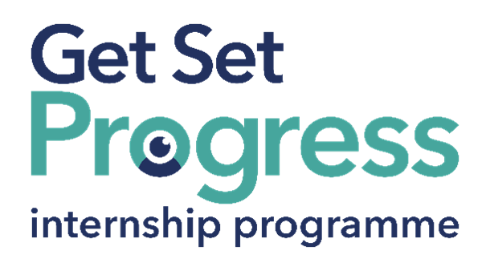

Programme Information Editor Intern

Join us at Channel 4

Thomas Pocklington Trust (TPT) and RNIB are collaborating with organisations from both the sight loss and wider charity sector as well as corporate organisations to create new opportunities for blind and partially sighted people to find employment through the Get Set Progress (GSP) Internship programme. Channel 4 is delighted to be offering an internship as part of the Get Set Progress scheme.

Why Channel 4?
Channel 4 is a broadcaster with a purpose. We're defined by our unique public service remit. Part of this means nurturing the talent that will help us fulfil it. So doing what you do best will enable us to do what we do best: creating innovative programmes and content that reflect the UK’s richly diverse cultural landscape.

We’re here to stimulate debate; to champion alternative points of view; and to inspire change in people’s lives. Whoever you are, whatever you do, you’ll be part of a proudly British Public Service Broadcaster. You’ll be part of who we are. So whether you’re just starting out in our industry or wondering where you can go next, we’ll happily be part of your journey.

Job description
Role: Programme Information Editor Intern
Department: Content Management
Reporting to: Rob Scott
Location: Leeds
Office days: 3 days in the office
Salary: Based on the Real Living Wage
Contract type: 37 hours per week, fixed Term, 9-month contract: October 2026-July 2027.

Purpose of the role:
The role is focused on managing the publication of programme information across the relevant systems, and collating and editing programme information in line with the department’s editorial policy for publication across EPGs, TV listings and streaming platforms for all Channel 4 channels.

Main responsibilities:
• Publication and ownership of listings and/or EPGs including publication of schedules, synopses and updates, while meeting regular deadlines
• Management and publication of editorial metadata for streaming platforms
• Editing high-quality, well-written, accurate programme information and metadata for streaming platforms, the Listings Site and EPGs
• Managing the workload efficiently and meeting regular publication deadlines
• Working flexibly, and completing any last-minute changes accurately and promptly
• Liaising with internal stakeholders and external contacts, and performing tasks to support the collective efforts of the Programme Information team
• Developing a good understanding of C4 systems and applications
• Working independently and building relationships with the department and stakeholders
• Ensuring that content is consistent with the department’s editorial policy

Person specification

Essential criteria
Important information:
- This role has a Genuine Occupational Requirement that the successful applicant be a person who is blind or partially sighted, in line with The Equality Act 2010.
- Interns need to be able to travel to the TPT Hub in London for development events throughout the course of the internship programme (costs covered by TPT).
- Having not previously undertaken the Get Set Progress internship programme.
- Successful applicants must have the Right to Work in the UK for the duration of the Internship. Sponsorship will not be provided.

Essential personal specifications
- Confident using a range of software and digital systems, with the ability to learn new technologies quickly and accurately input data across multiple platforms.
- Excellent attention to detail, with a high standard of accuracy, written communication, spelling and grammar.
- Strong analytical and questioning skills, with an awareness of editorial sensitivities and the importance of handling programme information appropriately.
- Self-motivated, proactive and able to take a hands-on approach to work.
- A flexible and adaptable approach to work, with the ability to prioritise competing tasks, manage deadlines and perform effectively under pressure.
- Strong interpersonal and communication skills, with the ability to build and maintain positive working relationships across multiple teams and locations.
- A collaborative team player, with the confidence to communicate effectively with colleagues at all levels while remaining calm and professional under pressure.
- An understanding of the importance of programme listings, Electronic Programme Guides (EPGs) and programme metadata, and their impact on the viewer experience.

Desirable personal specifications
- Experience of working on websites in an editorial and/or technical role is an advantage.

Closing date:
Friday, August 14. 17:00

How to apply
If you are interested in this role, please apply with your CV and a
300-word answer (max) to the following question:
Why are you applying to become the Programme Information Editor Intern at Channel 4?
Please send both documents to Hannah: HChester@channel4.co.uk with the subject “TPT / C4 Application – Programme Information Editor Intern”

As this role forms part of the Get Set Progress Internship Programme, we will share your name and email address with Thomas Pocklington Trust (TPT). This enables TPT to monitor participation in the Programme, confirm eligibility having not previously taken part and where appropriate, to offer employment support services to applicants who are unsuccessful. We process and share this information in accordance with UK GDPR and our recruitment privacy notice.

What are the benefits of a Get Set Progress internship for me?
As part of your 9-month internship, you will be part of a large cohort of fellow interns and gain the following:
- Obtain valuable work experience within the charity sector.
- Technology support, including Microsoft Office, and upskilling opportunities.
- Online and in-person training and development opportunities.
- Opportunity to present and network with senior leaders within the sight loss sector.
- Opportunities to build relationships with fellow interns.
- A personal mentor offering support, advice and guidance throughout your internship.
- Help deliver positive changes for people with sight loss.


As part of the GSP Internship programme, you will also be enrolled on the TPT Works For Me Employment Programme, where you will gain bespoke employment support, guidance and advice from the TPT Employment Team, some of the skills that you will receive support and guidance around include:
- CV writing.
- Job searching.
- Cover letter and speculative letter writing.
- Application form writing.
- Interview techniques.



Thomas Pocklington Trust (TPT) is a charity established to provide services for visually impaired people: our mission is to improve the lives of people living with sight loss.

TPT is registered with the Disability Confident Scheme as a Disability Confident employer. Therefore, we believe in treating all employees fairly and we are committed to recruiting equally. TPT’s charitable objective and aim is to support visually impaired individuals back into work. For this reason, we are actively seeking applications from all backgrounds including disabled/visually impaired individuals and people who have lived experience of sight loss. We also guarantee all disabled applicants that reach the minimum appointment criteria an interview. We are happy to accept applications from all suitably qualified people who have the appropriate skills and talent regardless of their age, gender, race, religion, disability, sexual orientation or marital status.

End of Document

