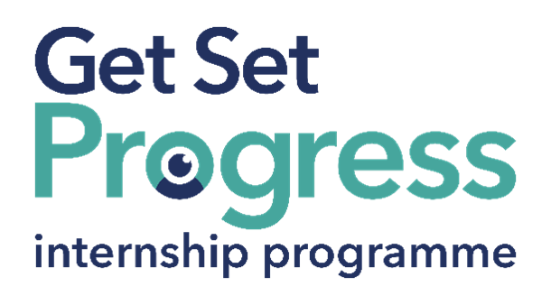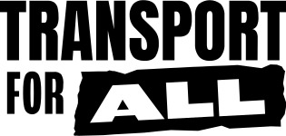

Admin Assistant Intern

Join us at Transport For All

Thomas Pocklington Trust (TPT) and RNIB are collaborating with organisations from both the sight loss and wider charity sector as well as corporate organisations to create new opportunities for blind and partially sighted people to find employment through the Get Set Progress (GSP) Internship programme. Transport for All is delighted to be offering an internship as part of the Get Set Progress scheme.

About Transport for All
Transport for All is the disabled-led group breaking down barriers and transforming the transport system so disabled people can make the journeys we want, with freedom, dignity, ease and confidence. We work with our members to campaign for change, influencing governments, industry and the public.

Job description
Role: Admin Assistant Intern
Department: Cross Department
Reporting to: Ella Lees, Fundraising Manager
Location: Remote
Salary: Based on the Real Living Wage
Contract type: Parttime (21 hours per week) Fixed Term, 9-month contract

Purpose of the role:
The primary purpose of this role is to support the successful delivery of Transport for All’s administration and organisational coordination activity. The role will support colleagues across the organisation with administrative processes, organisational systems and coordination activities, helping to ensure the smooth running of day-to-day work. The postholder will gain practical experience in administration, coordination and organisational support within a disabled-led organisation.

Main responsibilities:
Administration and coordination:
- Support meeting coordination, diary scheduling and administrative activity
- Assist with preparing agendas, meeting papers and action logs
- Help coordinate accessible meetings and events, including booking captions or other access support where required
- Support inbox monitoring and internal coordination activity
- Help maintain digital filing systems and organisational records
- Support data entry, CRM/database updates and information management processes
- Help format and prepare accessible documents and resources
- Support event coordination, online meeting setup and administrative logistics
- Assist with reporting, compliance and administrative processes
Organisational support:
- Support colleagues across teams with coordination and administrative tasks
- Assist with maintaining shared resources, templates and systems
- Help improve organisational processes and accessible ways of working
- Assist with maintaining accurate records and documentation
- Support membership administration and engagement systems
- Help maintain project trackers, calendars and coordination tools
- Provide general administrative and organisational support across the charity

Person specification

Essential criteria
Important information:
- This role has a Genuine Occupational Requirement that the successful applicant be a person who is blind or partially sighted, in line with The Equality Act 2010.
- Interns need to be able to travel to the TPT Hub in London for development events throughout the course of the internship programme (costs covered by TPT).
- Having not previously undertaken the Get Set Progress internship programme.
- Successful applicants must have the Right to Work in the UK for the duration of the Internship. Sponsorship will not be provided.

Essential personal specifications
- Interest in administration, coordination or organisational support
- Good communication and organisational skills
- Good attention to detail
- Basic IT skills including Microsoft Office
- Willingness to learn new systems and processes
- Interest in accessibility, inclusion and disabled people’s rights
- Commitment to equality, diversity and inclusion
- Commitment to using the Social Model of Disability in your work

Desirable personal specifications
- Experience using Microsoft Office or similar digital systems
- Interest in administration, coordination or project support
- Interest in supporting teams, projects and organisational activities
- Interest in accessible and inclusive ways of working

Closing date:
Monday 10th of August at 12:00pm

How to apply
Please visit Transport For All’s recruitment page for further information and how to apply for this position. For an informal discussion about the role, or to receive the documents in alternative formats, please contact: recruitment@transportforall.org.uk

What are the benefits of a Get Set Progress internship for me?
As part of your 9-month internship, you will be part of a large cohort of fellow interns and gain the following:
- Obtain valuable work experience within the charity sector
- Technology support (Including Microsoft Office) and upskilling opportunities
- Online and in-person Training and development opportunities
- Opportunity to present and network with Senior leaders within the Sight Loss Sector
- Opportunities to build relationships with fellow interns
- A personal mentor offering support, advice and guidance throughout your internship
- Help deliver positive changes for people with sight loss


As part of the GSP Internship programme, you will also be enrolled on the TPT Works For Me Employment Programme, where you will gain bespoke employment support, guidance and advice from the TPT Employment Team, some of the skills that you will receive support and guidance around include:
- CV writing
- Job searching
- Cover letter and speculative letter writing
- Application form writing
- Interview techniques

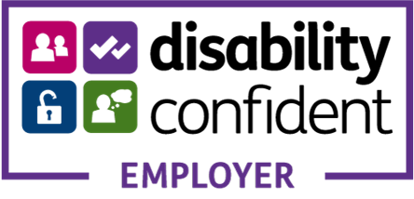

Thomas Pocklington Trust (TPT) is a charity established to provide services for visually impaired people: our mission is to improve the lives of people living with sight loss.

TPT is registered with the Disability Confident Scheme as a Disability Confident employer. Therefore, we believe in treating all employees fairly and we are committed to recruiting equally. TPT’s charitable objective and aim is to support visually impaired individuals back into work. For this reason, we are actively seeking applications from all backgrounds including disabled/visually impaired individuals and people who have lived experience of sight loss. We also guarantee all disabled applicants that reach the minimum appointment criteria an interview. We are happy to accept applications from all suitably qualified people who have the appropriate skills and talent regardless of their age, gender, race, religion, disability, sexual orientation or marital status.

End of Document

