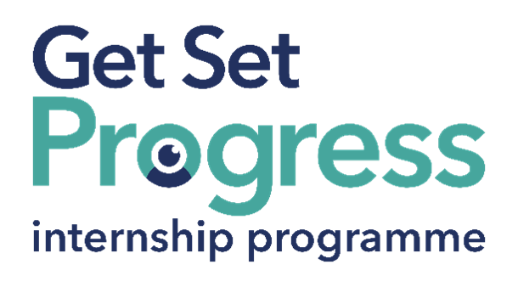

Customer Service Intern

Join us at Mavis Technologies

Thomas Pocklington Trust (TPT) and RNIB are collaborating with organisations from both the sight loss and wider charity sector as well as corporate organisations to create new opportunities for blind and partially sighted people to find employment through the Get Set Progress (GSP) Internship programme. Mavis Technologies is delighted to be offering 2 internships as part of the Get Set Progress scheme.

About Mavis Technologies
Mavis Technologies was established in August 2023, following the completion of our CEO’s master’s degree at the University of Northampton. Motivated by personal experience as a visually impaired individual, our CEO recognized the challenges faced by those with visual impairments and sought to create a company dedicated to developing assistive gadgets and smart glasses for the visually impaired and blind community. Drawing inspiration from the concept of empowerment and independence, the idea for Mavis was born, with a name derived from Magic and Vision, symbolizing our belief in creating solutions that empower individuals with low or no vision.

Our Vision
At Mavis, we are committed to developing cutting-edge smart glasses specifically designed for visually impaired and blind individuals. Our mission is to enhance the lives of people worldwide by providing innovative products that prioritize reliability, affordability, and user comfort. With a team of experienced professionals, we have successfully crafted a range of solutions that not only assist users in their daily lives but also inspire a sense of independence and autonomy. We strive to ensure that our products are not only technologically advanced but also meet the unique needs and preferences of our users. Mavis Technologies is dedicated to creating impactful solutions that enrich the lives of individuals with visual impairments, setting a standard for accessibility, innovation, and empowerment in the assistive technology industry.

Job description
Number of Roles: 2
Roles: Customer Support Intern
Department: Customer Support & Sales
Reporting to: David Sikharulidze
Location: Northampton, NN11EW. Office based with some opportunities for homeworking
Salary: Based on the Real Living Wage
Contract type: Fixed Term, 9-month contract, Part Time, 20 hours per week

Purpose of the roles:
We are seeking 2 motivated and organised Customer Support Interns to join our team. This is an excellent opportunity for someone looking to develop practical experience in customer-facing operations within a fast-moving technology environment. The intern will serve as a key point of contact for customers and prospects, ensuring queries are handled promptly, orders are managed effectively, and customer feedback is channelled back into the business.

Main responsibilities:
Customer Enquiries & Communication
- Respond promptly and professionally to inbound calls and emails from customers and prospective customers.
- Answer product and service questions clearly and accurately, ensuring a positive customer experience.
- Identify customer needs and match them to the appropriate products or services offered by Mavis Technologies.
- Escalate complex queries to the wider team and follow up to ensure resolution.
Order Management & Coordination
- Receive and process customer orders accurately, ensuring all details are captured and confirmed.
- Coordinate with internal teams to oversee fulfilment and delivery progress.
- Proactively communicate order updates and delivery timelines to customers.
- Resolve any order discrepancies or delivery issues efficiently and professionally.

After-Sales Support
- Conduct structured after-sales follow-ups with customers to ensure satisfaction and address any outstanding concerns.
- Build ongoing relationships with customers to encourage retention and repeat business.
- Identify opportunities for upselling or cross-selling additional products and services where appropriate.

Essential personal specifications
- Strong verbal and written communication skills — confident speaking with customers by phone and email.
- Highly organised with good attention to detail; able to manage multiple tasks and priorities.
- A customer-first mindset with a genuine desire to help and solve problems.
- Comfortable using digital tools and software (e.g., email, CRM systems).
- Proactive and self-motivated; able to work independently as well as part of a small team.
- An interest in technology or commercial operations is advantageous but not essential.

Person specification

Essential criteria
Important information:
- This role has a Genuine Occupational Requirement that the successful applicant be a person who is blind or partially sighted, in line with The Equality Act 2010.
- Interns need to be able to travel to the TPT Hub in London for development events throughout the course of the internship programme (costs covered by TPT).
- Having not previously undertaken the Get Set Progress internship programme.
- Successful applicants must have the Right to Work in the UK for the duration of the Internship. Sponsorship will not be provided.

Essential personal specifications
- Strong verbal and written communication skills — confident speaking with customers by phone and email.
- Highly organised with good attention to detail; able to manage multiple tasks and priorities.
- A customer-first mindset with a genuine desire to help and solve problems.
- Comfortable using digital tools and software (e.g., email, CRM systems).
- Proactive and self-motivated; able to work independently as well as part of a small team.
- An interest in technology or commercial operations is advantageous but not essential.

Closing date:
Wednesday 5 August at 17:00

How to apply
Send your CV and a short cover letter at jobs@mavistech.uk telling us why you'd like to join Mavis Technologies

What are the benefits of a Get Set Progress internship for me?
As part of your 9-month internship, you will be part of a large cohort of fellow interns and gain the following:
- Obtain valuable work experience within the charity sector
- Technology support (Including Microsoft Office) and upskilling opportunities
- Online and in-person Training and development opportunities
- Opportunity to present and network with Senior leaders within the Sight Loss Sector
- Opportunities to build relationships with fellow interns
- A personal mentor offering support, advice and guidance throughout your internship
- Help deliver positive changes for people with sight loss


As part of the GSP Internship programme, you will also be enrolled on the TPT Works For Me Employment Programme, where you will gain bespoke employment support, guidance and advice from the TPT Employment Team, some of the skills that you will receive support and guidance around include:
- CV writing
- Job searching
- Cover letter and speculative letter writing
- Application form writing
- Interview techniques



Thomas Pocklington Trust (TPT) is a charity established to provide services for visually impaired people: our mission is to improve the lives of people living with sight loss.

TPT is registered with the Disability Confident Scheme as a Disability Confident employer. Therefore, we believe in treating all employees fairly and we are committed to recruiting equally. TPT’s charitable objective and aim is to support visually impaired individuals back into work. For this reason, we are actively seeking applications from all backgrounds including disabled/visually impaired individuals and people who have lived experience of sight loss. We also guarantee all disabled applicants that reach the minimum appointment criteria an interview. We are happy to accept applications from all suitably qualified people who have the appropriate skills and talent regardless of their age, gender, race, religion, disability, sexual orientation or marital status.

End of Document

