
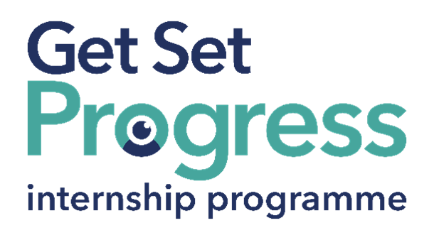

Administrator Intern

Join us at General Optical Council (GOC)

Thomas Pocklington Trust (TPT) and RNIB are collaborating with organisations from both the sight loss and wider charity sector as well as corporate organisations to create new opportunities for blind and partially sighted people to find employment through the Get Set Progress (GSP) Internship programme. GOC is delighted to be offering an internship as part of the Get Set Progress scheme.

About GOC
We are the regulator for the optical professions in the UK. We currently register around 33,000 optometrists, dispensing opticians, student optometrists and dispensing opticians, and optical businesses.
We have four core functions:
- Setting standards for the performance and conduct of our registrants.
- Approving qualifications leading to registration.
- Maintaining a register of individuals who are fit to practise or train as optometrists or dispensing opticians, and bodies corporate who are fit to carry on business as optometrists or dispensing opticians.
- Investigating and acting where registrants’ fitness to practise, train or carry on business may be impaired.

Our Values
Our values underpin the way we work with each other, and with the public, you and partner organisations:
- We act with integrity
- We pursue excellence
- We respect other people and ideas
- We show empathy
- We behave fairly
- We are agile and responsive to change

Our mission
- Our mission is to protect the public by upholding high standards in eye care services.
- Our vision
- Our vision is safe and effective eye care for all.
- Our values
- Our values underpin the way we work with each other, you and partner organisations:
- We act with integrity
- We pursue excellence
- We respect other people and ideas
- We show empathy
- We behave fairly
- We are agile and responsive to change.

Job description
Role: Administrator Intern
Department: Various
Reporting to: Jo Murphy
Location: Hybrid, Canary Wharf, London, E14 5AA
Salary: Based on the Real Living Wage
Contract type: Fulltime (37.5 hours per week) Fixed Term, 9-month contract

Purpose of the role:
To provide flexible administrative and project support across the organisation, helping to ensure the smooth delivery of day-to-day operations and key initiatives.

Main responsibilities:
- Provide general administrative support across the organisation, including processing requests, maintaining records and supporting routine processes.
- Support the coordination and delivery of projects and initiatives, including scheduling, communications and follow-up actions.
- Draft and issue correspondence, ensuring appropriate approvals are obtained where required.
- Maintain and update records, trackers and databases to support accurate reporting and oversight.
- Liaise with colleagues at all levels to gather information, provide updates and ensure timely completion of tasks.
- Support internal processes such as onboarding administration, documentation checks and record keeping.
- Contribute to internal communications, including intranet updates and news items where needed.
- Support the organisation and delivery of internal meetings, training sessions and events.
- Assist with the coordination of organisational initiatives, including wellbeing and engagement activities.
- Provide ad hoc administrative support across different areas of the organisation as required, including occasional front-of-house or facilities-related support

Person specification

Essential criteria
Important information:
- This role has a Genuine Occupational Requirement that the successful applicant be a person who is blind or partially sighted, in line with The Equality Act 2010.
- Interns need to be able to travel to the TPT Hub in London for development events throughout the course of the internship programme (costs covered by TPT).
- Having not previously undertaken the Get Set Progress internship programme.
- Successful applicants must have the Right to Work in the UK for the duration of the Internship. Sponsorship will not be provided.

Essential personal specifications
- Experience of providing administrative support in a professional environment (this could include internships, placements, or voluntary work).
- Comfortable using Microsoft Office tools, particularly Excel, Outlook and Word, with the ability to manage and update basic data and records accurately.
- Strong organisational skills, with the ability to manage multiple tasks and prioritise effectively.
- Good written and verbal communication skills, with the confidence to draft emails and communicate clearly with colleagues.
- A proactive and flexible approach, with the willingness to support a range of tasks across different areas of the organisation.
- Good attention to detail, particularly when handling data, documentation and processes.
- Ability to build positive working relationships with colleagues at different levels.

Desirable personal specifications
- Experience of using systems such as SharePoint or similar document management tools.
- Some experience of supporting projects, events or internal initiatives.
- Awareness of or interest in equality, diversity and inclusion.
- Experience gained within a public, regulatory or not-for-profit setting.

Closing date:
Proposed 12 Aug, 17:00

How to apply
Please click the link below to apply through the website:
Administrator Intern - 9 Months FTC job - One Canada Square, London - The General Optical Council

What are the benefits of a Get Set Progress internship for me?
As part of your 9-month internship, you will be part of a large cohort of fellow interns and gain the following:
- Obtain valuable work experience within the charity sector
- Technology support (Including Microsoft Office) and upskilling opportunities
- Online and in-person Training and development opportunities
- Opportunity to present and network with Senior leaders within the Sight Loss Sector
- Opportunities to build relationships with fellow interns
- A personal mentor offering support, advice and guidance throughout your internship
- Help deliver positive changes for people with sight loss


As part of the GSP Internship programme, you will also be enrolled on the TPT Works For Me Employment Programme, where you will gain bespoke employment support, guidance and advice from the TPT Employment Team, some of the skills that you will receive support and guidance around include:
- CV writing
- Job searching
- Cover letter and speculative letter writing
- Application form writing
- Interview techniques



Thomas Pocklington Trust (TPT) is a charity established to provide services for visually impaired people: our mission is to improve the lives of people living with sight loss.

TPT is registered with the Disability Confident Scheme as a Disability Confident employer. Therefore, we believe in treating all employees fairly and we are committed to recruiting equally. TPT’s charitable objective and aim is to support visually impaired individuals back into work. For this reason, we are actively seeking applications from all backgrounds including disabled/visually impaired individuals and people who have lived experience of sight loss. We also guarantee all disabled applicants that reach the minimum appointment criteria an interview. We are happy to accept applications from all suitably qualified people who have the appropriate skills and talent regardless of their age, gender, race, religion, disability, sexual orientation or marital status.

End of Document

