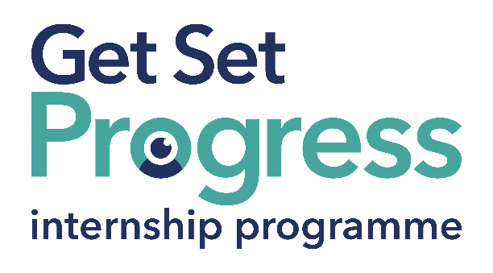

SLC Conference and Awards Coordinator Intern

Join us at Thomas Pocklington Trust

Thomas Pocklington Trust is a national charity dedicated to delivering positive change to blind and partially sighted people.
Our mission is to support blind and partially sighted people of all ages to live the life they want to lead
Our values define everything we do:
Making a difference: The lives of blind and partially sighted people are better because of what we do.
Working in partnership: We work collaboratively together and with all our partners and stakeholders.
Respect: We treat people the way we would like to be treated.
Quality: We set clear goals and high standards and work efficiently and effectively to achieve them.
Participation: We place the participation of blind and partially sighted people at the heart of everything we do.
Thomas Pocklington Trust aims to be a fulfilling and enjoyable place to work; we know this enthusiasm plays a key role in delivering high quality services for blind and partially sighted people, we also recognise the crucial role each and every one of us plays in helping to achieve our goals.

What are the benefits of a Get Set Progress internship for me?

As part of your 9-month internship, you will be part of a large cohort of fellow interns and gain the following:
- Obtain valuable work experience within the charity sector
- Technology support (Including Microsoft Office) and upskilling opportunities
- Online and in-person Training and development opportunities
- Opportunity to present and network with Senior leaders within the Sight Loss Sector
- Opportunities to build relationships with fellow interns
- A personal mentor offering support, advice and guidance throughout your internship
- Help deliver positive changes for people with sight loss

As part of the GSP Internship programme, you will also be enrolled on the TPT Works For Me Employment Programme, where you will gain bespoke employment support, guidance and advice from the TPT Employment Team, some of the skills that you will receive support and guidance around include:
- CV writing
- Job searching
- Cover letter and speculative letter writing
- Application form writing
- Interview techniques

Job description
Role: SLC Conference Coordinator Intern
Department: Engagement
Reporting to: Head of Engagement
Location: Hybrid – London Hub based at least 2 days per week
Salary: Based on the Real Living Wage
Contract type: Fixed Term, 9-month contract, Full time, 36 hours a week

Job Specification Information

Job purpose: Overview of the role:

To coordinate the planning and organisation of the forthcoming Sight Loss Councils Conference and Rodney Powell Awards, taking place between 5 to 7 June 2026, in central Birmingham.

Areas of Responsibility:

- Coordination of the planning sub-groups, ensuring they meet regularly and come together as a full planning group each month.
- Working with TPT’s Engagement and Education Teams to deliver an exciting Conference and Awards event.
- Overseeing the development and implementation of the events plan, ensuring the planning subgroups are meeting deadlines and have everything they need.
- Liaising with the venue to ensure the smooth planning and running of the event.
- Support the smooth running of the event, on the day, ensuring volunteers get a great experience. This will include overseeing the registration desk and assisting volunteers with their queries.
- Liaising with suppliers and overseeing any conference merchandise or other orders etc.
- Support any communications to volunteers, about the event.
- Coordinating the evaluation of the event.
- This list of duties is an overview of the role; the list is not exhaustive and other ad hoc duties will be required.

Person specification
This post has a Genuine Occupational Requirement that the successful applicant be a person who is blind or partially sighted, in line with The Equality Act 2010
- Willingness to travel to the TPT Hub in London for intern development events throughout the course of the internship programme.
- Having not previously undertaken the Get Set Progress internship programme.

The successful applicant will possess the following skills:
Essential:
- Ability to organise events and/or activities.
- Good organisation skills.
- Ability to manage own workload and meet deadlines.
- Ability to priorities work and tasks.
- Good communication skills, both written and verbal.
- Ability to communicate with different audiences, including staff and volunteers across the organisation.
- Ability to build and maintain relationships both internally and externally.
- Ability to manage several different tasks, at the same time.

Desirable:
- An understanding of the principles of event management.
- Experience of organising or attending national Conferences or Awards events.

What to do next

If you are interested in this role, please email a completed application and equal opportunities monitoring form to:
applications@pocklington.org.uk.

About Thomas Pocklington Trust



Thomas Pocklington Trust (TPT) is a charity established to provide services for visually impaired people: our mission is to improve the lives of people living with sight loss.

TPT is registered with the Disability Confident Scheme as a Disability Confident employer. Therefore, we believe in treating all employees fairly and we are committed to recruiting equally. TPT’s charitable objective and aim is to support visually impaired individuals back into work. For this reason, we are actively seeking applications from all backgrounds including disabled/visually impaired individuals and people who have lived experience of sight loss. We also guarantee all disabled applicants that reach the minimum appointment criteria an interview. We are happy to accept applications from all suitably qualified persons who have the appropriate skills and talent regardless of their age, gender, race, religion, disability, sexual orientation or marital status.

End of Document

