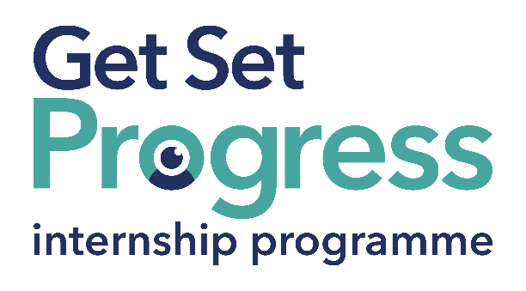

Administration Officer

Join us at Vision North Somerset
Thomas Pocklington Trust (TPT) and RNIB are collaborating with organisations from both the sight loss and wider charity sector as well as corporate organisations to create new opportunities for blind and partially sighted people to find employment through the Get Set Progress (GSP) Internship programme. Vision North Somerset is delighted to be offering an internship as part of the Get Set Progress scheme.

Vision North Somerset is the leading charity supporting people affected by sight and hearing loss in North Somerset through a wide range of tailored services and support. We are proud of the wide range of services delivered by our small, dedicated team and fantastic volunteers.

Our Purpose
We are here to help as many people with sight loss and hearing impairment across North Somerset as effectively as we can.
We have clear Vision, Mission and Value statements that we work to.

Vision
Vision North Somerset is working to support people with sight loss and those with a hearing impairment to participate fully in our community, enjoying the same opportunities to reach their full potential as people who are fully sighted.

Mission
Our Mission is to make a positive difference to the lives of people with sight loss and hearing impairment in North Somerset by providing support, advice, social activities and the skills to enable them to reach their full potential and lead independent lives.

Values
To enable us to achieve the above, Vision North Somerset operates under the following values:
Service user led: People with sight loss and those with a hearing impairment are at our heart and influence everything that we do.
Collaborative: We are passionate about working together, both within Vision North Somerset and with partners, to ensure that we make the biggest difference possible
Innovative: We deal with challenges in a positive and imaginative way to find a way forward.
Inclusive: We include and value people with diverse experience, abilities and backgrounds.
Open: We are honest, candid and transparent, working with integrity in all that we do.

What are the benefits of a Get Set Progress internship for me?
As part of your 9-month internship, you will be part of a large cohort of fellow interns and gain the following:
- Obtain valuable work experience within the charity sector
- Technology support (Including Microsoft Office) and upskilling opportunities
- Online and in-person Training and development opportunities
- Opportunity to present and network with Senior leaders within the Sight Loss Sector
- Opportunities to build relationships with fellow interns
- A personal mentor offering support, advice and guidance throughout your internship
- Help deliver positive changes for people with sight loss


As part of the GSP Internship programme, you will also be enrolled on the TPT Works For Me Employment Programme, where you will gain bespoke employment support, guidance and advice from the TPT Employment Team, some of the skills that you will receive support and guidance around include:
- CV writing
- Job searching
- Cover letter and speculative letter writing
- Application form writing
- Interview techniques

Job description
Role: Intern Administration Officer
Department: Organisation-wide
Reporting to: CEO/Operations Manager
Location: Office-based at 3 Neva Road, Weston-Super-Mare
Salary: Based on the Real Living Wage
Contract type: Fixed term, 9-months, full-time – 37 hours a week

Job Specification Information

Job purpose: Overview of the role:
To support the CEO and other staff with administration tasks to enable the smooth running of charity services and operations.

If you are looking for a role where you will be offered the opportunity to work across all areas of the charity, including supporting the Rehabilitation Officer, Sight Loss Advisors, CEO, Operations Manager, Volunteers and Administrator, you have come to the right place. As an Intern, we will give you the opportunity to see how many different roles operate while providing admin support to the team. Vision North Somerset is in a time of transition, we offer a supportive, collaborative environment and if you are motivated by seeing how your contribution makes a positive impact on the lives of people affected by sight and hearing loss, you could be just who we are looking for!!

Why is this role so critical to us?

The Intern will work with all members of the team to support with all Vision North Somerset’s activities, including service delivery, financial processing and communications.

Key areas of responsibility:
- Managing postal and email communication including GDPR and data security
- Support the team with regular postal and email communication including making a contribution to our quarterly newsletter.
- Work with Vision North Somersets database
- Support staff with data entry to the database.
- Office/facilities management/Health and Safety
- Support the Administrator with ordering office and catering supplies, help with managing the cleaner and trade people doing small repairs as needed.
- Support with managing bookings for the Bradbury room.

Personal specification - Essential criteria:
This post has a Genuine Occupational Requirement that the successful applicant be a person who is blind or partially sighted, in line with The Equality Act 2010
- Willingness to travel to the TPT Hub in London for intern development events throughout the course of the internship programme (costs covered by TPT).
- Having not previously undertaken the Get Set Progress internship programme.
- Lived experience of sight loss
- Excellent communication skills, both verbal and written, and the ability to communicate with a wide range of different people and with different communication needs.
- Excellent administration and organisational skills.
- Fluent in Microsoft Outlook and Office suite
- Willingness to travel to various locations across North Somerset to support activities and events.
- A keenness to be part of a small, mutually supportive team.
- Interest and passion for the charity sector, especially for supporting people with sight loss and hearing impairment to be able to lead the lives they want to lead.
Personal specification – desirable criteria:
- CRM experience

What to do next
Please send your CV and a covering letter outlining how you meet the person specification to tracie.tappenden@visionns.org.uk

Closing date
17:00 22nd of September 2025

