Retail Reimagined: Making Retail More Accessible for

Blind and Partially Sighted People

Feedback on Accessible QR Codes from Blind and Partially

Sighted Consumers

A report by Young Voices at Thomas Pocklington Trust

Contents

Thomas Pocklington Trust Young Voices 2
Executive Summary 2
Introduction 3
Methodology 5
Participant Demographics 5
Key Findings 5
Awareness vs. Usage 5
Desired Information via QR Codes 5
Preferred Product Categories 6
Preferred Retailers and Brands 6
Accessibility Tools Currently Used 6
Knowledge and Perception of Navilens/ZapVision 7
Conclusion 7
Recommendations 8
Appendix 1 9

Thomas Pocklington Trust Young Voices
The Young Voices group are a student group of volunteers with lived experience of sight loss, who work on projects aimed at improving the lived experience of blind and partially sighted people. All projects are student-led, supported by staff at Thomas Pocklington Trust. This project has been championed by a few members of the Young Voices group. You can find out more about the programme and meet some of those involved here: Student Voices and Young Voices - Thomas Pocklington Trust

Executive Summary
This report analyses feedback from 29 blind and partially sighted consumers regarding accessible QR codes, such as those developed by Navilens and ZapVision, within retail environments. Key findings highlight a notable gap between awareness and usage: while 59% of respondents were aware of the technology, only 31% had used it, and just 24% had specifically used Navilens or ZapVision.

There is strong demand for these codes to provide clear, comprehensive product information—particularly ingredients, allergens, usage instructions, expiry dates, and pricing. This is especially important for essential items such as food, clothing, medications, and cosmetics. Respondents expressed a desire for implementation across major supermarkets like Tesco, Asda, Sainsbury’s, Morrisons, and M&S, health and beauty stores such as Boots and Superdrug, and key clothing retailers.

At present, consumers rely heavily on smartphone apps such as Seeing AI, Be My Eyes, magnifiers, and human assistance to support their shopping experiences. Awareness of specific providers like Navilens and ZapVision is generally low, with most information sourced through specialist sight loss organisations rather than mainstream retail channels. Feedback from users who had tried the technology was mixed, pointing to varying levels of ease and usefulness.

In summary, accessible QR codes represent a valuable tool that meets a clear need. However, their effectiveness is limited by low adoption, limited rollout by retailers, lack of brand awareness, and usability barriers. Addressing these issues will require stronger retailer engagement, wider promotion through inclusive channels, and a greater focus on user-friendly design and education.

Introduction
The Young Voices team at Thomas Pocklington Trust set out to investigate the barriers blind and partially sighted consumers face in retail settings, with a particular focus on accessing product information. While shopping is a routine task for most people, it can present significant challenges for those with vision impairments especially when identifying products, reading labels, or accessing critical details such as ingredients, allergens, expiry dates, and instructions.

Accessible QR codes offer a promising way to bridge this information gap. Navilens and ZapVision are applications designed to support blind and partially sighted individuals in accessing detailed product information independently using smartphones. Unlike traditional barcodes, which require precise alignment and often feature small, monochrome designs, Navilens codes are brightly coloured, high-contrast, and can be detected from a distance and varied angles. Navilens have developed their own app to be used to scan the codes and find the information. ZapVision offers another approach to embedding accessible data by using a traditional QR code in the middle but then adding dots and dashes around one corner of the code. This design increases the detection and scanning distance for users and can be used with a phone’s camera, just like a standard QR code.

Examples of these two accessible QR codes are below:
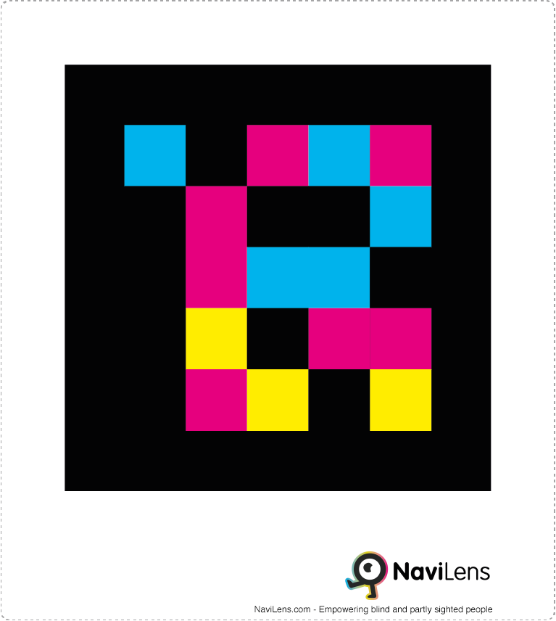
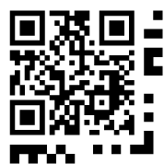

Figure 1: An example of a
Navilens Accessible QR Code.
Figure 2: An example of a
ZapVision Accessible QR Code

[Image Description. Figure 1, on the left, shows an example of a Navilens accessible QR code. A square black box with different smaller squares, like pixels in the middle in blue, pink and yellow colours. Figure 2, on the right, is an example of a ZapVision accessible QR code. A traditional black and white QR code in the middle with longer black dots and dashes around the outside to the bottom and right of the standard QR code]

Despite their potential, these solutions remain underused. This research seeks to better understand the level of awareness, usage patterns, preferences, and the overall effectiveness of accessible QR codes in real-world settings. The insights shared come directly from blind and partially sighted individuals with lived experience.

This project ultimately aims to inform retailers, developers, and policymakers on how best to implement accessible QR technology to ensure that shopping is more inclusive, independent, and empowering for all consumers.

Methodology
Data was collected through a questionnaire distributed to blind and partially sighted consumers using Microsoft Forms. The survey included both multiple-choice and open-ended questions covering demographics, awareness and usage of accessible QR codes, preferred information formats, product categories, brand preferences, and use of other accessibility tools (See Appendix 1). Responses were analysed to identify trends in both quantitative and qualitative data.

Participant Demographics
A total of 29 individuals took part in the survey, all of whom identified as blind or partially sighted. Respondents came from across England, with the highest concentrations in Yorkshire and the Humber (8 participants) and the South East (7 participants). Other regions represented included the East Midlands (4), London (4), West Midlands (2), South West (2), East of England (1), and North West (1). Notably, there were no responses from the North East.

Most participants were aged 18–24 or 25–34, followed by those aged 55–64. Regarding gender, 17 identified as women and 12 as men.

Key Findings

Awareness vs. Usage
Although more than half of the respondents (59%) were aware of accessible QR codes, significantly fewer had used them. Only nine respondents (31%) had ever scanned one, and just seven (24%) had used codes from Navilens or ZapVision specifically. This reflects a considerable gap between awareness and practical access or knowledge on how to use the technology.

Desired Information via QR Codes
Respondents expressed a clear desire for detailed and structured product information via accessible QR codes. For food items, common requests included ingredients, allergens, nutritional content, cooking instructions, expiry dates, dietary suitability (e.g. vegan), portion sizes, and pricing. For clothing, key information needed was size, fabric composition, colour, care instructions, and price. Regarding medication and cosmetics, users wanted usage instructions, ingredients, potential allergens or side effects, and scent descriptions. Generally, manufacturer details, product specifications, and accessibility features were also desired. Some participants emphasised the importance of accessing key information quickly without lengthy descriptions.

Preferred Product Categories
Respondents wanted accessible QR codes implemented on a wide variety of products. Everyday groceries, toiletries and personal care items, clothing, medication and health products, and household goods were most frequently mentioned. Several also suggested books, stationery, greetings cards, electronics, and pet food. A common sentiment was that codes should ideally be present on "everything" or at least "all products with small print" that is difficult to read.

Preferred Retailers and Brands
Participants named a broad range of retailers where they would like to see accessible QR codes implemented. Supermarkets such as Tesco, Asda, Sainsbury’s, Morrisons, Aldi, M&S, and Waitrose were frequently cited. In health and beauty, Boots and Superdrug were prominent mentions. Fashion shops included Primark, M&S, John Lewis, Next, River Island, New Look, and Sports Direct. Other mentioned shops were WHSmith, Poundland, B&M, Waterstones, HMV, alongside specific brands like Nike and Schwartz spices. There was a strong call for widespread implementation across all major retailers and particularly on store-brand products.

Accessibility Tools Currently Used
In the absence or limited availability of accessible QR codes, respondents rely on a range of existing tools and strategies. Smartphone apps like Seeing AI, Be My Eyes, and Envision AI, along with built-in magnifier functions, are commonly used. Low-tech aids such as handheld magnifiers and long canes also play a role. Furthermore, human support, whether through services like Aira, shopping with friends or family, or requesting assistance from in-store staff, remains crucial. Some noted inconsistent results when trying to scan traditional barcodes with apps, highlighting the need for more reliable alternatives.

Knowledge and Perception of Navilens/ZapVision
Overall knowledge of the specific providers, Navilens and ZapVision, was low among respondents. Many had only heard the names or were unsure of how the technology worked in practice. Information about these systems was primarily acquired through channels related to the sight loss community, such as work, college, sight loss organisations, or word-of-mouth from other blind and partially sighted individuals, rather than through mainstream retailers or advertising.

Among the few who had used the technology, opinions on its usefulness and ease of use were mixed. Some found the systems intuitive and helpful, while others encountered difficulties with functionality or understanding the process. Usage was generally infrequent, often limited to demonstrations or specific test environments rather than routine application in everyday retail settings.

Conclusion
There is a strong need for accessible QR codes among blind and partially sighted consumers. These tools offer a potential pathway to greater independence by providing access to essential product information. However, current awareness and usage levels remain low, and detailed understanding of specific technologies like Navilens and ZapVision is often limited to those already connected within specialist networks.

While these technologies show promise, their real-world impact is currently constrained. Broader adoption by major retailers is needed, alongside clear communication channels informing potential users how to access and utilize these tools effectively. Improvements to usability, informed by user feedback, are also essential. The voices of those directly affected highlight a desire for practical, reliable solutions that function seamlessly in everyday shopping environments, across the wide range of products and brands they encounter.

Recommendations
To improve the visibility, usability, and effectiveness of accessible QR codes for blind and partially sighted consumers, several key actions are recommended. We aim to influence retailers, developers and policymakers on how best to implement accessible QR technology to ensure shopping is more inclusive, independent and empowering for all customers.

First, it is crucial to raise awareness and provide targeted education. This involves launching campaigns specifically for blind and partially sighted consumers explaining how accessible QR codes work, which apps are compatible, and identifying participating retailers and brands. Communication should extend beyond specialist sight loss networks to include mainstream platforms and potentially in-store information.

Second, wider retailer adoption must be encouraged. Collaboration with major supermarkets, health and beauty chains, and clothing stores is needed to implement codes on both own-brand and popular third-party products, prioritising essential categories like food, medication, and personal care items.

Third, the content delivered via codes must be relevant, consistent and well-structured. Information should be clear, concise, and organised with headings suitable for screen reader navigation, allowing users to quickly find key details like ingredients, instructions, or price. There should be a standardised positioning on products, so they are easy to find (e.g. on the front right-hand side). The sight loss sector, including Thomas Pocklington Trust, could create guides outlining how to create effective QR codes to businesses. This could be used to provide a standardised experience across the industry.

Appendix 1

Questionnaire used to collect feedback on Accessible QR Codes which informed this report.

Accessible QR code experiences - A Thomas Pocklington Trust Young Voices Project.

Young Voices is made up of blind and partially sighted young people from the UK. They're passionate about improving the lives of other blind and partially sighted people so wanted to focus their efforts on the world of retail. They think that accessible QR codes could revolutionise the shopping experience so want to gather YOUR experiences and opinions to help them make plans for what to do next. Thank You!

About you

- Do you consider yourself to be blind or partially sighted even without a formal diagnosis?
  - Yes
  - No

- What region do you live in?
  - North East
  - North West
  - Yorkshire and the Humber
  - East Midlands
  - West Midlands
  - East of England
  - London
  - South East
  - South West
  - Prefer not to say
  - Other

- How old are you?
  - Under 18
  - 18-24
  - 25-34
  - 35-44
  - 45-54
  - 55-64
  - 65+
  - Prefer not to say

- How would you describe your gender?
  - Woman/female
  - Man/male
  - Non-binary
  - Prefer not to say
  - Other

Accessible QR Codes
Accessible QR codes help people who are blind or have low vision, access crucial product information on packaging from product names and ingredients to recipe ideas and usage instructions.

- Have you heard of accessible QR codes such as those created by Navilens and ZapVision?
  - Yes
  - No

- Have you ever used an accessible QR code such as those created by Navilens and ZapVision?
  - Yes
  - No

- If you were to use an accessible QR code, what information would you want to be able to find out about a product? For example, allergies, ingredients, how to use etc.

[Free text box to complete]

- What type of products would you like to see accessible QR codes on? For example food, cosmetics, clothing etc. Please list as many as you'd like.

[Free text box to complete]

- Are there any specific brands, companies or shops you would like to see them on? For example Nike, Tesco, John Lewis. Please list as many as you'd like

[Free text box to complete]

- What other types of accessible tools do you use to support you whilst shopping other than accessible QR codes?

[Free text box to complete]

Navilens and/or Zapvision

- What do you know about these companies?

[Free text box to complete]

- Do you use their accessible QR codes?
  - Yes
  - No

- Do you find their accessible QR codes useful and easy to use?
  - Yes
  - No

- Where did you find out about Navilens and/or Zapvision?

[Free text box to complete]

- When was the last time you used either Navilens and/or Zapvision and what was it for?

[Free text box to complete]

