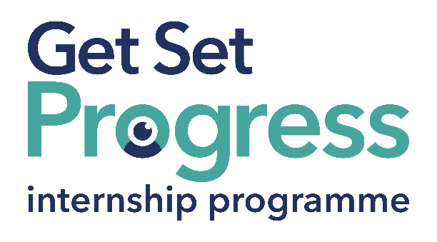

Volunteer and Publicity Co-ordinator

Join us at Lincoln & Lindsey Blind Society
Thomas Pocklington Trust (TPT) and RNIB are collaborating with organisations from both the sight loss and wider charity sector as well as corporate organisations to create new opportunities for blind and partially sighted people to find employment through the Get Set Progress (GSP) Internship programme. Lincoln & Lindsey Blind Society is delighted to be offering an internship as part of the Get Set Progress scheme.

About Lincoln & Lindsey Blind Society

Lincoln & Lindsey Blind Society exists to enhance the quality of life of blind, partially sighted and visually impaired people whatever their age or circumstances in life.

What are the benefits of a Get Set Progress internship for me?
As part of your 9-month internship, you will be part of a large cohort of fellow interns and gain the following:
- Obtain valuable work experience within the charity sector
- Technology support (Including Microsoft Office) and upskilling opportunities
- Online and in-person Training and development opportunities
- Opportunity to present and network with Senior leaders within the Sight Loss Sector
- Opportunities to build relationships with fellow interns
- A personal mentor offering support, advice and guidance throughout your internship
- Help deliver positive changes for people with sight loss



As part of the GSP Internship programme, you will also be enrolled on the TPT Works for Me Employment Programme, where you will gain bespoke employment support, guidance and advice from the TPT Employment Team, some of the skills that you will receive support and guidance around include:
- CV writing
- Job searching
- Cover letter and speculative letter writing
- Application form writing
- Interview techniques

Job Description
Role: Volunteer and Publicity Coordinator
Department: Volunteer and Publicity
Reporting to: Mandy Johnson
Location: Ramsgate Louth (Minimum of 3 days a week within the Office)
Salary: Based on the Real Living Wage
Contract type: Fixed Term, 9-month contract, fulltime,36 hours per week.

Job Specification Information
- To be responsible for supporting volunteers to assist the Society and its clients.
- To co-ordinate, support and supervise volunteers on a day-to-day basis.
- To oversee the organisation of social clubs and other activities for visually impaired people, in co-operation with volunteers where practical.
- To develop increased levels of awareness of Lincoln & Lindsey Blind Society within the community.

Key areas of Responsibility:
- Supporting volunteers
- Supervising volunteers
- Oversee the social groups of the Society
- increase levels of awareness of the Society

Person Specification - Essential Criteria:
This post has a Genuine Occupational Requirement that the successful applicant must be a person who is blind or partially sighted, in line with The Equality Act 2010
- Willingness to travel to the TPT Hub in London for intern development events throughout the course of the internship programme (costs covered by TPT).
- Having not previously undertaken the Get Set Progress internship programme.
- Good communication skills

What to do next
If this sounds like the opportunity for you:
• Please contact our main office on 01507 605604 or email mandy@llbs.co.uk for a job description and application form.
• Complete the application form and send it to: mandy@llbs.co.uk

Closing Date
Monday 14 July.

END OF DOCUMENT

