
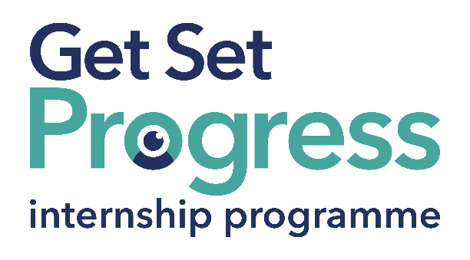

Role: Service Management Analyst (Admin Role)

Join us at Tialis Essential IT Manage Ltd

Thomas Pocklington Trust (TPT) and RNIB are collaborating with organisations from both the sight loss and wider charity sector as well as corporate organisations to create new opportunities for blind and partially sighted people to find employment through the Get Set Progress (GSP) Internship programme. Tialis Essential IT Manage Ltd is delighted to be offering an internship as part of the Get Set Progress scheme.

About Tialis Essential IT Manage Ltd

Tialis is an IT managed service provider. We offer full IT support from managed services, professional services for adhoc projects, to device lifecycle management for any company’s devices and their users.

We are an exciting, vibrant place to work, where no two days are ever the same. Employee contribution is key as we work together to reach our shared goals and create something truly exceptional.

At Tialis, our people are at the heart of everything we do. That’s why “Putting People First” is one of our core strategic pillars. We are committed to building a culture that focuses on:

Loyalty and Commitment – Fostering a workplace where trust, dedication, and long-term relationships thrive.

Talent Development – Growing a strong pipeline of future leaders and experts.

Staying Current and Competitive – Embracing innovation and staying ahead of the curve in the services that we provide.

Future Ready Skills – Equipping our people with the tools and knowledge they need to grow and succeed.

We want our employees to thrive here to bring their best, challenge themselves, and enjoy the dynamic people first culture we are proud of.

Our Values

Collaboration: We thrive by working together and recognising the strength of our team.

Excellence: We are determined to deliver for our customers and strive to delight with our services.

Ethical: We believe in helping organisations thrive without compromising on the future.

Agile: We never stand still. If there is a better way to do something, we deliver it.

Honest: We are open, fair, and always act with integrity. Our customers trust us to be true to our word.

Ownership: We always deliver our best, holding ourselves accountable for results.

What are the benefits of a Get Set Progress internship for me?
As part of your 9-month internship, you will be part of a large cohort of fellow interns and gain the following:
- Obtain valuable work experience within the charity sector.
- Technology support (Including Microsoft Office) and upskilling opportunities.
- Online and in-person Training and development opportunities
- Opportunity to present and network with Senior leaders within the Sight Loss Sector
- Opportunities to build relationships with fellow interns.
- A personal mentor offering support, advice, and guidance throughout your internship.
- Help deliver positive changes for people with sight loss.

As part of the GSP Internship programme, you will also be enrolled on the TPT Works For Me Employment Programme, where you will gain bespoke employment support, guidance and advice from the TPT Employment Team, some of the skills that you will receive support and guidance around include:

- CV writing
- Job searching
- Cover letter and speculative letter writing.
- Application form writing
- Interview techniques


Job description
Role: Service Management Analyst
Department: Admin - Lifecycle
Reporting to: Amy Bauer
Location: Greenhithe Dartford
Salary: Based on the Real Living Wage
Contract type: Fixed Term, 9-month contract, full-time (37.5 hours per week)

Job Specification Information

Job Description:

Responsible for Administrative duties within the IT Lifecycle Service Management and Asset Configuration Management function.

Key Responsibilities:
- Maintain records and databases containing information regarding requests, changes, owner, and locations for the organization’s IT Hardware Assets.

- Complete data entry to query and enter information for Asset Request, Supply, Acquisition, Returns and Inventory purposes.

- Control the identification, receipt, delivery, and collection of assets from point to point within the agreed client service framework.

- Record the identification, storage, and withdrawal of all client assets in the Lifecycle Stores on the configuration management database.

- Scheduling, tracking and management of courier deliveries and collections, Obtaining Proof of Delivery and resolving the related calls or queries.

- Perform periodic asset discovery and audit tasks of physical assets within the Lifecycle Warehouse

- Perform periodic asset discovery and audit tasks of the configuration management database.

- Handling client queries daily and providing the requisite response/update on all related activities within the service framework.

- Coordinating with client users or designated representatives on reporting and chronicling of information regarding lost/stolen/recovery of assets on configuration management database.

- Record all asset information from clients relating to the IT Asset estate on the configuration management database e.g., hardware upgrades and repairs.

- Generating periodic reports agreed within the service framework as well as reporting on request for the Service Management Team.

- Achieve and maintain a configuration management database accuracy rate of 98% or higher at all times.

- Maintaining and Filing of all hard copy records on Lifecycle Services transactions.

Personal specification
Essential criteria:
This post has a Genuine Occupational Requirement that the successful applicant must be a person who is blind or partially sighted, in line with The Equality Act 2010
- Good Organisation Skills.
- Good Communication Skills.
- Excellent work ethic and ability to work within a team.

Experience:
- knowledge of Microsoft Office Packages.
- Customer Service Experience
- Basic knowledge of producing MS Excel based reports and formulas.
- Willingness to travel to the TPT Hub in London for intern development events throughout the course of the internship programme (costs covered by TPT).
- Having not previously undertaken the Get Set Progress internship programme.

What to do next

How to apply – please send your CV with a cover letter to careers@tialis.com

Closing date :

18 July 2025

END OF DOCUMENT

