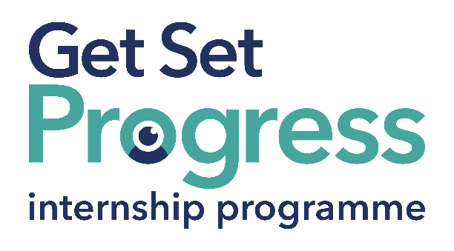

Employment Intern

Join us at Thomas Pocklington Trust

Thomas Pocklington Trust is a national charity dedicated to delivering positive change for blind and partially sighted people.
Our mission is to support blind and partially sighted people of all ages to live the life they want to lead.
Our values define everything we do:
Making a difference: The lives of blind and partially sighted people are better because of what we do.
Working in partnership: We work collaboratively together and with all our partners and stakeholders.
Respect: We treat people the way we would like to be treated.
Quality: We set clear goals and high standards and work efficiently and effectively to achieve them.
Participation: We place the participation of blind and partially sighted people at the heart of everything we do.
Thomas Pocklington Trust aims to be a fulfilling and enjoyable place to work; we know this enthusiasm plays a key role in delivering high quality services for blind and partially sighted people, we also recognise the crucial role each and every one of us plays in helping to achieve our goals.

What are the benefits of a Get Set Progress internship for me?
As part of your 9-month internship, you will be part of a large cohort of fellow interns and gain the following:
- Obtain valuable work experience within the charity sector
- Technology support (Including Microsoft Office) and upskilling opportunities
- Online and in-person Training and development opportunities
- Opportunity to present and network with Senior leaders within the Sight Loss Sector
- Opportunities to build relationships with fellow interns
- A personal mentor offering support, advice and guidance throughout your internship
- Help deliver positive changes for people with sight loss


As part of the GSP Internship programme, you will also be enrolled on the TPT Works For Me Employment Programme, where you will gain bespoke employment support, guidance and advice from the TPT Employment Team, some of the skills that you will receive support and guidance around include:
- CV writing
- Job searching
- Cover letter and speculative letter writing
- Application form writing
- Interview techniques

Job Description
Role: Employment Intern
Department: Employment
Reporting to: Employment Manager
Location: London/Hybrid
Salary: Based on the Real Living Wage
Contract type: Fixed Term, 9 month contract, 36 hours per week.

Job Specification
Overview of the role:

To support TPT’s Works For Me and Get Set Progress Internship programmes. To be the first point of call for clients into our service and to contribute to the smooth running of the Employment Team through the completion of support and administrative tasks.
Main Duties:

- To respond to phone calls and emails from job seekers and (with training) and to act as first contact for new clients of the Works For Me Employment Programme or the Get Set Progress Internship Programme.
- To develop casework and advice skills, to be able to provide advice and manage cases throughout the internship.
- To learn to input client information into the Salesforce database.
- To support the Employment Team, including taking minutes of meetings.
- Any other relevant task as directed by the Employment Manager, Development Manager, Head of Employment.

This list of duties is an overview of the role; the list is not exhaustive and other ad hoc duties will be required.

Person Specification:

This post has a Genuine Occupational Requirement that the successful applicant be a person who is blind or partially sighted, in line with The Equality Act 2010.
- Willingness to travel to the TPT Hub in London for intern development events throughout the course of the internship programme (costs covered by TPT).
- Having not previously undertaken the Get Set Progress internship programme.

The successful applicant will possess the following skills:

Essential Criteria

- Communicate with energy and enthusiasm.
- Ability to problem solve.
- Ability to learn to negotiate and influence
- Good communications skills, both written and verbal.
- Understanding of the barriers faced by blind and partially sighted people in gaining employment
- A desire to learn and develop skills that support the role

The successful applicant will be able to travel independently and be comfortable working in an environment with Guide Dogs.

What to do next
If you are interested in this role, please email a completed application and diversity monitoring form to:
applications@pocklington.org.uk.

Closing Date
5 pm on 14 July

About Thomas Pocklington Trust



Thomas Pocklington Trust (TPT) is a charity established to provide services for visually impaired people: our mission is to improve the lives of people living with sight loss.

TPT is registered with the Disability Confident Scheme as a Disability Confident employer. Therefore, we believe in treating all employees fairly and we are committed to recruiting equally. TPT’s charitable objective and aim is to support visually impaired individuals back into work. For this reason, we are actively seeking applications from all backgrounds including disabled/visually impaired individuals and people who have lived experience of sight loss. We also guarantee all disabled applicants that reach the minimum appointment criteria an interview. We are happy to accept applications from all suitably qualified persons who have the appropriate skills and talent regardless of their age, gender, race, religion, disability, sexual orientation or marital status.

End of Document

