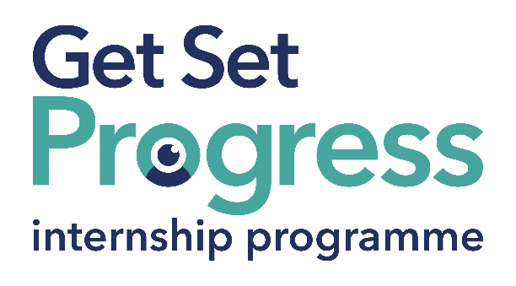

Development Team Project Assistant Intern
Join us at Thomas Pocklington Trust

Thomas Pocklington Trust is a national charity dedicated to delivering positive change for blind and partially sighted people.
Our mission is to support blind and partially sighted people of all ages to live the life they want to lead.
Our values define everything we do:
Making a difference: The lives of blind and partially sighted people are better because of what we do.
Working in partnership: We work collaboratively together and with all our partners and stakeholders.
Respect: We treat people the way we would like to be treated.
Quality: We set clear goals and high standards and work efficiently and effectively to achieve them.
Participation: We place the participation of blind and partially sighted people at the heart of everything we do.
Thomas Pocklington Trust aims to be a fulfilling and enjoyable place to work; we know this enthusiasm plays a key role in delivering high quality services for blind and partially sighted people, we also recognise the crucial role each and every one of us plays in helping to achieve our goals.

As part of your 9-month internship, you will be part of a large cohort of fellow interns and gain the following:
- Obtain valuable work experience within the charity sector
- Technology support (Including Microsoft Office) and upskilling opportunities
- Online and in-person Training and development opportunities
- Opportunity to present and network with Senior leaders within the Sight Loss Sector
- Opportunities to build relationships with fellow interns
- A personal mentor offering support, advice and guidance throughout your internship
- Help deliver positive changes for people with sight loss

As part of the GSP Internship programme, you will also be enrolled on the TPT Works For Me Employment Programme, where you will gain bespoke employment support, guidance and advice from the TPT Employment Team, some of the skills that you will receive support and guidance around include:
- CV writing
- Job searching
- Cover letter and speculative letter writing
- Application form writing
- Interview techniques

Job Description

Role: Development Team Project Assistant Intern
Department: Employment Team
Reporting to: Development Manager
Location: Hybrid home/TPT Hub
Salary: Based on the Real Living Wage
Contract type: Fixed Term, 9-month contract, 36 hours per week

Job Specification Information
Overview of the Role:
To assist in the development, delivery and evaluation of in-person and online courses for blind and partially sighted jobseekers.

Main Duties:
- Co-ordination and administration of courses for jobseekers
- Promotion of sessions through multimedia including the development of videos and sound files
- Supporting blind and partially sighted people to access activities, this might be by providing information, technical advice or encouragement.
- Recording all activities and plans on the Salesforce database
- Creation of exciting and informative activities to support blind and partially sighted people become job ready
- Evaluation of activities
- Delivering activities as appropriate
- This list of duties is an overview of the role, the list is not exhaustive and other ad hoc duties will be required, which support TPT Employment Team

Person Specification
This post has a Genuine Occupational Requirement that the successful applicant be a person who is blind or partially sighted, in line with The Equality Act 2010.
- Willing to travel to the TPT Hub in London for intern development events throughout the course of the internship programme (costs covered by TPT).
- Having not previously undertaken the Get Set Progress internship programme.

The successful candidate will possess the following skills:

Essential criteria
- Good communications skills, both written and verbal.
- A good understanding of assistive technologies for blind and partially sighted people
- A competent user of Microsoft products Word, Outlook, Teams, Excel
- Understanding of the barriers faced by blind and partially sighted people in gaining employment
- Be well organised and self-motivated
- A desire to learn and develop skills that support the role

What to do next
If you are interested in this role, please email a completed application and diversity monitoring form to applications@pocklington.org.uk

Closing Date: 5 pm on 14 July

About Thomas Pocklington Trust:


Thomas Pocklington Trust (TPT) is a charity established to provide services for visually impaired people: our mission is to improve the lives of people living with sight loss.

TPT is registered with the Disability Confident Scheme as a Disability Confident employer. Therefore, we believe in treating all employees fairly and we are committed to recruiting equally. TPT’s charitable objective and aim is to support visually impaired individuals back into work. For this reason, we are actively seeking applications from all backgrounds including disabled/visually impaired individuals and people who have lived experience of sight loss. We also guarantee all disabled applicants that reach the minimum appointment criteria an interview. We are happy to accept applications from all suitably qualified persons who have the appropriate skills and talent regardless of their age, gender, race, religion, disability, sexual orientation or marital status.

End of Document

