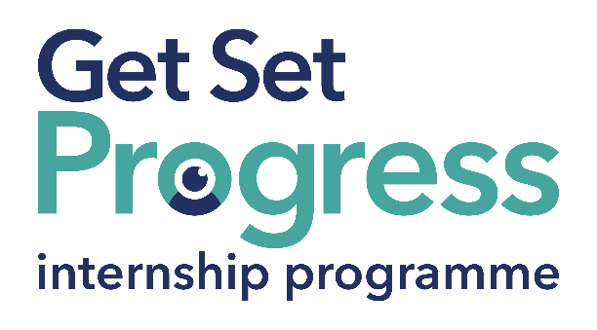
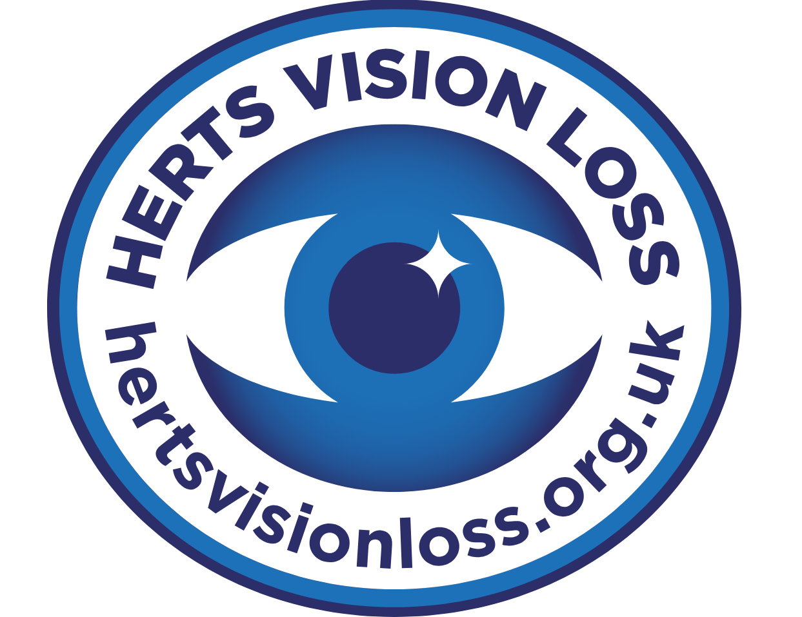

Assistive Technology Support Intern

Join us at Herts Vision Loss
Thomas Pocklington Trust (TPT) and RNIB are collaborating with charities in the sight loss sector to create new opportunities for blind and partially sighted people to find employment through the Get Set Progress Internship programme. Herts Vision Loss (HVL) is delighted to be offering an internship as part of the Get set Progress scheme.
With over a century of experience, Herts Vision Loss has evolved into a dynamic organisation offering a wide range of tailored services designed to meet the practical, emotional, and social needs of blind and visually impaired individuals. Our approach is inclusive and person-centred, focusing on removing barriers to independence, improving wellbeing, and enhancing quality of life. We support individuals of all ages and backgrounds, from children and young people to older adults, through services that are accessible, compassionate, and impact driven.
Our Values
Excellence: We are committed to pursuing the highest possible standards at every level of the charity. We have the expertise, experience, and knowledge to offer a professional yet personal and caring approach.

Community: We are committed to an inclusive, positive environment in which clients, volunteers, employees, and trustees may experience a sense of belonging, respect and worth.

Empowerment: We are committed to encouraging, motivating, and inspiring everyone to enable them to reach their full potential and demonstrate that sight loss need not signify the end of or be a barrier to independence, capacity and worth.

Support: We aim to make a difference in the lives of those we support by putting their needs at the heart of everything we do. We support, trust and empower our clients, volunteers, employees and trustees to further the shared mission of Herts Vision Loss.

Integrity: We are honest, reliable, loyal, and transparent in the way we deliver our services.

What are the benefits of a Get Set Progress internship for me?
As part of your 9-month internship, you will be part of a large cohort of fellow interns and gain the following:
- Obtain valuable work experience within the charity sector.
- Technology support (Including Microsoft Office) and upskilling opportunities.
- Online and in-person Training and development opportunities.
- Opportunity to present and network with Senior leaders within the Sight Loss Sector.
- Opportunities to build relationships with fellow interns.
- A personal mentor offering support, advice, and guidance throughout your internship.
- Help deliver positive changes for people with sight loss.


As part of the GSP Internship programme, you will also be enrolled on the TPT Works For Me Employment Programme, where you will gain bespoke employment support, guidance, and advice from the TPT Employment Team, some of the skills that you will receive support and guidance around include:
- CV writing.
- Job searching.
- Cover letter and speculative letter writing.
- Application form writing.
- Interview techniques.

Job Description

Role: Assistive Technology Support Intern
Department: Organisation-wide
Reporting to: CEO
Location: Hybrid, Welwyn Garden City Herts Vision Loss office.
Salary: Based on Living Wage Foundation rates
Contract type: Fixed Term nine months, full time 36 hours per week.

Job Purpose:

The Assistive Technology Support Intern will play a key role in supporting blind and visually impaired individuals across Hertfordshire to gain greater independence, digital inclusion, and confidence using assistive technology. This internship is part of Herts Vision Loss’s commitment to increasing lived experience employment and empowering visually impaired individuals to lead fulfilling and independent lives.

Key Areas of Responsibility
- Provide one-to-one and group-based training sessions on assistive technology tools such as screen readers (JAWS, NVDA), magnification software (ZoomText), and accessible features on smartphones and tablets.
- Assist service users in setting up and optimising devices to suit their individual needs and levels of vision.
- Support users in understanding and navigating websites, apps, and digital platforms using accessible tools.
- Document individual user progress and feedback for monitoring and evaluation purposes.
- Assist in raising awareness of assistive technology within Herts Vision Loss support groups, community events, and stakeholder sessions.
- Gather feedback from service users on the effectiveness of assistive technology support and recommend improvements.
- Attend regular team meetings and supervision sessions.
- Actively engage in personal development activities, mentoring, and training opportunities provided through the Get Set Progress programme.
- Support colleagues and contribute to a collaborative working environment.
- Maintain professional boundaries and confidentiality when supporting individuals.

Person specification
The successful applicant will possess the following skills:

Essential criteria
- This post has a Genuine Occupational Requirement that the successful applicant be a person who is blind or partially sighted, in line with The Equality Act 2010.
- Willingness to travel to the TPT Hub in London for intern development events throughout the course of the internship programme (costs covered by TPT).
- Having not previously undertaken the Get Set Progress internship programme.
- Strong Interest in assistive technology that supports independent living for blind and partially sighted individuals.
- Familiar with commonly used technology such as smartphones, tablets, computers, and accessibility features (e.g. screen readers, magnifiers, voice assistants).
- Able to explain concepts clearly and sensitively to individuals with a range of technical confidence levels.
- Comfortable speaking to individuals one-to-one or in small groups.
- Works well collaboratively and is willing to support colleagues and volunteers across the organisation.
- Awareness of the importance of maintaining service user confidentiality and appropriate conduct in a support role.

What to do next
If you are interested in applying for the above vacancy, please send your CV and a covering letter explaining why we should employ you as an intern to: Clement.Musonda@hertsvisionloss.org.uk or give us a call on 01707 324 680.
Closing Date: Monday 14 July 2025

About Herts Vision Loss
Herts Vision Loss (HVL) is a dedicated charity supporting blind and visually impaired individuals across Hertfordshire. With a mission to reduce social isolation and promote independence, HVL provides a wide range of services including assistive technology support, counselling, hospital eye clinic liaison, and community engagement. The organisation is committed to empowering people with sight loss to lead fulfilling lives through tailored support, training, and advocacy.
HVL has been recognised for its outstanding community impact, including receiving The King’s Award for Voluntary Service in 2024, the highest accolade for volunteer groups in the UK. HVL also recently won the national Charity Governance Award for Improving Impact in Small Charities.
Herts Vision Loss is committed to fair, inclusive, and accessible recruitment practices. According to our recruitment and interviewing policy, HVL ensures that:

- All appointments are made based on merit and the ability to perform the role.
- The organisation complies with all relevant legal requirements, including the Equality Act 2010.
- Reasonable adjustments are made to accommodate applicants and employees with disabilities.
HVL also has a dedicated equal opportunities and diversity that reinforces its commitment to promoting equality and preventing discrimination.
HVL is a Disability Confident Employer with a strong commitment to disability inclusion and lived experience employment.

