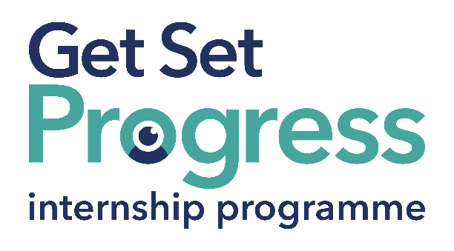

Marketing and Events Intern

Join us at Sensory Matters Worcestershire
Thomas Pocklington Trust (TPT) and RNIB are collaborating with organisations from both the sight loss and wider charity sector as well as corporate organisations to create new opportunities for blind and partially sighted people to find employment through the Get Set Progress (GSP) Internship programme. Sensory Matters Worcestershire (formerly known as Sight Concern Worcestershire) is delighted to be offering an internship as part of the Get Set Progress scheme.

About Sensory Matters Worcestershire

Our vision:
A world where sensory impaired people have the confidence to lead fulfilling lives.

Our purpose:
We will give sensory impaired people the support they need to make choices about their own lives.

Our key strategic objectives:
- To ensure everyone living with sensory impairment in Worcestershire knows who we are and where they can find the support they need from the start of their journey.
- To provide a range of good quality, high impact services which support people after their diagnosis.
- To provide a range of emotional and practical support to ensure that people live well with their sensory loss.
- To always keep the people we support at the centre of our work.
- To create a strong, sustainable, agile and adaptable charity which is able to act on opportunities for development and growth.

What are the benefits of a Get Set Progress internship for me?
As part of your 9-month internship, you will be part of a large cohort of fellow interns and gain the following:
- Obtain valuable work experience within the charity sector
- Technology support (Including Microsoft Office) and upskilling opportunities
- Online and in-person Training and development opportunities
- Opportunity to present and network with Senior leaders within the Sight Loss Sector
- Opportunities to build relationships with fellow interns
- A personal mentor offering support, advice and guidance throughout your internship
- Help deliver positive changes for people with sight loss


As part of the GSP Internship programme, you will also be enrolled on the TPT Works For Me Employment Programme, where you will gain bespoke employment support, guidance and advice from the TPT Employment Team, some of the skills that you will receive support and guidance around include:
- CV writing
- Job searching
- Cover letter and speculative letter writing
- Application form writing
- Interview techniques

Job Description
Role: Marketing and Events Intern
Department: Community Engagement and Fundraising
Reporting to: Alice Linforth
Location: Hybrid, at least 3 days in the office / The Bradbury Centre, 2 Sansome Walk, Worcester, WR1 1LH
Salary: Based on the Real Living Wage
Contract type: Fixed Term, 9 months Full time – 37.5 hours a week

Job Specification Information

Overview of the Role:
To develop and deliver a blend of engaging communications which demonstrate, share and celebrate the services offered by Sensory Matters Worcestershire.
To develop internal and external communications.
To plan and deliver, with colleagues, a range of information and fundraising events.

Key areas of responsibility:

- Marketing and Communications:
- Develop the charity’s social media presence through the creation and engaging and informative social media posts.
- Design and produce marketing literature, information and campaigns to promote the charity’s services in a variety of accessible formats.
- Support with the creation and production of our quarterly newsletter.
- Support the planning, delivery and promotion of Sensory Matters Worcestershire information events.
- Help with the preparation of timely press releases and identify opportunities to create regular news articles.
- Maintain, update and develop the charity’s website.
2. Fundraising:

- Support the planning, delivery and promotion of charity fundraisers and events.
- Design and produce fundraising campaigns.
- Support the fundraising committee.
3. Community Engagement:
- Seek opportunities to promote the charity and its services in a variety of ways.
- Support a team of Community Ambassador volunteers to promote the work of Sensory Matters Worcestershire.
- Build relationships with other charities, professionals and organisations across Worcestershire to promote the charity’s services.
4. General:
The following points are common to all job descriptions
- Use our CRM system in an effective and efficient manner.
- Attend training, supervision and appraisals as and when appropriate.
- Adhere to legislative and organisational policy and procedure.
- Assist in the planning and improving of the delivery of service improvement and participate positively in the implementation of new working methods and practices as required.
Carry out any additional duties, commensurate with this post, that the charity may reasonably require.

Essential Criteria

The successful applicant will possess the following skills:

Specialist Knowledge, Skills and Experience:
- Knowledge and experience of using social media platforms.
- Understanding of the impact of sensory loss/impairment on access to information and how to overcome these barriers.
- Ability to think creatively and to use a variety of methods to communicate information.

Team working skills:
- Ability to engage and interact confidently with clients and colleagues in a professional manner.
- Willingness to be active part of a small but ambitious team
- Ability to engage and inspire volunteers.

Planning and organisational skills:
- Ability to organise work and time effectively, prioritise, set realistic timescales and meet deadlines.
- Ability to collate and maintain information electronically and manually.
- Ability to deliver within timescales or deadlines.
- Problem-solving and creative skills
- Ability to take responsibility for own actions and make decisions without referring to others in appropriate situations and act on own initiative.
- Ability to take an active role in finding to solutions.
- Communication skills
- Ability to communicate effectively, both verbally and in writing, adapting style to suit the audience.
- Ability to build effective relationships with a range of individuals, professionals and organisations, with the ability to inspire confidence.
- Ability to communicate with colleagues ensuring appropriate information is shared.
- Equal opportunities
- Ability to understand and demonstrate commitment to Sensory Matters Worcestershire’s Equal Opportunities Policy and to ensure all activities are consistent with the Equal Opportunities Policy.

Special conditions:
- Lived experience of sight loss.
- Must be prepared to travel across Worcestershire, using Access to Work to support where appropriate.
- Flexibility to work occasional weekends and evenings

This role is eligible for an enhanced DBS check for adults as the post holder will be working with adults with sight loss who could be perceived as vulnerable. The post holder will not engage in regulated activity therefore a check of the barred list is not permitted:

- To ensure that volunteers are effectively mentored in their work supporting clients.
- Understand and take appropriate steps to identify and manage risks, behaviours, and concerns to protect vulnerable adults and maintain their right to self-determination.

This post has a Genuine Occupational Requirement that the successful applicant be a person who is blind or partially sighted, in line with The Equality Act 2010
- Understanding of the issues and barriers faced by people with a visual impairment.

How to Apply
Please send a CV and covering letter to Katy at k.wakefield@sightconcern.co.uk

Closing Date
Monday 14 July 2025 by 12:00 pm
Interviews will be week commencing 21 July 2025

