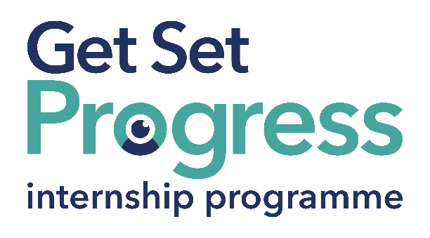

Communications Intern

Join us at Thomas Pocklington Trust

Thomas Pocklington Trust is a national charity dedicated to delivering positive change blind and partially sighted people.
Our mission is to support blind and partially sighted people of all ages to live the life they want to lead.
Our values define everything we do:
Making a difference: The lives of blind and partially sighted people are better because of what we do.
Working in partnership: We work collaboratively together and with all our partners and stakeholders.
Respect: We treat people the way we would like to be treated.
Quality: We set clear goals and high standards and work efficiently and effectively to achieve them.
Participation: We place the participation of blind and partially sighted people at the heart of everything we do.
Thomas Pocklington Trust aims to be a fulfilling and enjoyable place to work; we know this enthusiasm plays a key role in delivering high quality services for blind and partially sighted people, we also recognise the crucial role each and every one of us plays in helping to achieve our goals.

What are the benefits of a Get Set Progress internship for me?
As part of your 9-month internship, you will be part of a large cohort of fellow interns and gain the following:
- Obtain valuable work experience within the charity sector
- Technology support (Including Microsoft Office) and upskilling opportunities
- Online and in-person Training and development opportunities
- Opportunity to present and network with Senior leaders within the Sight Loss Sector
- Opportunities to build relationships with fellow interns
- A personal mentor offering support, advice and guidance throughout your internship
- Help deliver positive changes for people with sight loss

As part of the GSP Internship programme, you will also be enrolled on the TPT Works For Me Employment Programme, where you will gain bespoke employment support, guidance and advice from the TPT Employment Team, some of the skills that you will receive support and guidance around include:

- CV writing
- Job searching
- Cover letter and speculative letter writing
- Application form writing
- Interview techniques

Job Description

Role: Communications Intern
Department: Communications
Reporting to: Communications Manager
Location: Hybrid (1 day at the TPT Hub) with travel to our London office
Salary: Based on the Real Living Wage
Contract type: Fixed Term, 9 month contract, 36 hours per week

Job Specification
Overview of the role:

This role will support the day-to-day delivery of internal communications at Thomas Pocklington Trust. The successful candidate will help create engaging, accessible content for staff, coordinate internal events, and support communication projects that bring our organisational values to life. This is an exciting opportunity for someone who wants to gain experience in communications and make a difference in the lives of blind and partially sighted people.

Main Duties

- Content Creation and Planning
  - Assist in drafting internal newsletters, staff announcements and intranet articles.
  - Write engaging, accessible content that reflects the tone and values of TPT.
  - Help maintain an internal content calendar and keep it up to date.

- Staff Engagement and Campaign Support
  - Contribute ideas to improve how we share information with staff.
  - Support the delivery of campaigns to increase staff engagement and awareness.
  - Help coordinate internal events, staff briefings or celebration campaigns.

- Design Visual Content
  - Create basic graphics or presentations using tools such as Canva, Adobe Express and Descript for videos (training will be provided if needed).
  - Assist in formatting visually appealing and accessible internal documents.

- Monitoring and Feedback
  - Support the collection and analysis of staff feedback, including surveys and polls.
  - Help track engagement with internal comms channels (e.g., viva engage, internal staff emails).
  - Contribute to monthly team reports and summaries.

- Collaboration and Admin Support
  - Liaise with other teams to gather content and share updates across the organisation.
  - Help maintain comms mailbox and digital filing systems, (SharePoint).
  - Attend internal team meetings and take minutes when required.

Special Requirements

The role is home-based, with the requirement to be in our London office one day per week. There will also be opportunities to attend events or staff meetups in London.

A willingness to work in an environment that is inclusive of guide dogs and other access needs.
This list of duties is an overview of the role, the list is not exhaustive and other ad hoc duties will be required.

Person Specification
This post has a Genuine Occupational Requirement that the successful applicant be a person who is blind or partially sighted, in line with The Equality Act 2010
- Willingness to travel to the TPT Hub in London for intern development events throughout the course of the internship programme (costs covered by TPT).
- Having not previously undertaken the Get Set Progress internship programme.

Essential Skills:

- Awareness of internal communications and why it matters
- Understanding of accessible communications
- Possess an understanding of the needs of blind and partially sighted people
- Good communications skills, both written and verbal.
- Ability to organise tasks and meet deadlines
- Confident using digital tools (e.g., Excel, online research, databases)
- Must be able to develop and sustain effective professional relationships with internal and external contacts
- A commitment to work in accordance with the principles of equality and diversity
- A flexible approach and willingness to learn and develop

Desirable Criteria:
- Experience creating written content (e.g., blogs, newsletters, or social media posts)
- Experience using basic design or document formatting tools
- Experience of an Office or Admin setting
- Confidence to contribute ideas and ask questions

What to do next
If you are interested in this role, please email a completed application and diversity monitoring form to: applications@pocklington.org.uk.

Closing date
14th of July by 17:00

About Thomas Pocklington trust



Thomas Pocklington Trust (TPT) is a charity established to provide services for visually impaired people: our mission is to improve the lives of people living with sight loss.

TPT is registered with the Disability Confident Scheme as a Disability Confident employer. Therefore, we believe in treating all employees fairly and we are committed to recruiting equally. TPT’s charitable objective and aim is to support visually impaired individuals back into work. For this reason, we are actively seeking applications from all backgrounds including disabled/visually impaired individuals and people who have lived experience of sight loss. We also guarantee all disabled applicants that reach the minimum appointment criteria an interview. We are happy to accept applications from all suitably qualified persons who have the appropriate skills and talent regardless of their age, gender, race, religion, disability, sexual orientation or marital status.

End of Document

