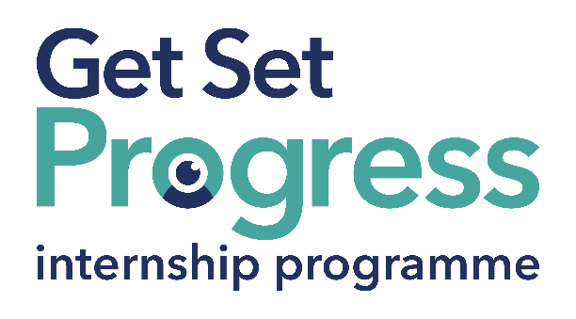

Finance Assistant Internship

Join us at Deafblind UK
Thomas Pocklington Trust (TPT) and RNIB are collaborating with organisations from both the sight loss and wider charity sector as well as corporate organisations to create new opportunities for blind and partially sighted people to find employment through the Get Set Progress (GSP) Internship programme. Deafblind UK is delighted to be offering an internship as part of the Get Set Progress scheme.

At Deafblind UK we want everyone living with deafblindness to receive the personalised and specialised services they need, at every stage of their life.

Our Values
Communication
We will always endeavour to communicate with people using their preferred language or method. We will communicate frequently, be open and honest and ensure the message we are communicating is clear, concise and will not cause offence.
Excellence
We will do our very best in all we undertake. We will work collaboratively and take responsibility for the outcomes. We will aim to inspire, take a pride in what we do and deliver our services efficiently and effectively.
Person centred
We will listen to the people we support and deliver services that best meet their individual needs and empower them to live the lives they choose. We will treat everyone with dignity and compassion.
Respect
We respect people for who they are and for their knowledge, skills and experience as individuals and team members. We will respect each other’s views and opinions, and when necessary, challenge constructively, positively and politely.

What are the benefits of a Get Set Progress internship for me?
As part of your 9-month internship, you will be part of a large cohort of fellow interns and gain the following:
- Obtain valuable work experience within the charity sector
- Technology support (Including Microsoft Office) and upskilling opportunities
- Online and in-person Training and development opportunities
- Opportunity to present and network with Senior leaders within the Sight Loss Sector
- Opportunities to build relationships with fellow interns
- A personal mentor offering support, advice and guidance throughout your internship
- Help deliver positive changes for people with sight loss

As part of the GSP Internship programme, you will also be enrolled on the TPT Works For Me Employment Programme, where you will gain bespoke employment support, guidance and advice from the TPT Employment Team, some of the skills that you will receive support and guidance around include:
- CV writing
- Job searching
- Cover letter and speculative letter writing
- Application form writing
- Interview techniques

Job Description
Role: Finance Assistant Intern
Department: Finance
Reporting to: Emma Sharpe
Location: Hybrid
Salary: Based on the Real Living Wage
Contract Type: Fixed Term, 9 month contract (37.5 hours per week)

Job Specification

Overview of the Role:
To provide a pro-active and professional administration support function to the Finance Department.
Key Areas of Responsibility:
- Daily cash processing – ensure that all daily income is recorded including cheques, credit card income, cash and bank transaction downloads and reconciled onto the SAP B1 accounting system.
- Processing of purchase ledger transactions, including purchase orders and supplier invoices. Preparation and processing of supplier payment runs.
- Processing of staff expense claims. Inputting and checking as required. Flagging issues of non-compliance as per the expense policy.
- Issuing of sales invoices to customers, accurately and promptly.
- Entering chargeable hours worked by staff via data upload to the accounting system.
- Support and assist with month-end processes and procedures, contributing towards production of the monthly Income & Expenditure Account. Entry of the annual budget into the accounting system.

Personal Specification - Essential Criteria:
This post has a Genuine Occupational Requirement that the successful applicant be a person who is blind or partially sighted, in line with The Equality Act 2010
- Experience of using IT systems including MS Office, especially Excel.
- Clear understanding, knowledge, or experience of accounting principles.
- Good attention to detail and thorough.
- Numerate and comfortable working with figures.
- Confident problem solver.
- Well organised with the ability to work to tight deadlines.
- Previous experience of working in a finance and accounting role and/or environment (desirable)
Preferred experience of the charitable/not for profit sector (desirable).
- Willingness to travel to the TPT Hub in London for intern. development events throughout the course of the internship programme (costs covered by TPT).
- Having not previously undertaken the Get Set Progress internship programme.

How to Apply
Please send CV and covering letter outlining how you meet the Job Description & Person Specification to rod.cullen@deafblind.org.uk

Closing date: Monday 14 July

About Deafblind UK
We welcome and actively encourage applications from people who have disabilities. If you require any support at your interview, for example, communication support or an interpreter, please tell us in your application or when we invite you to interview.

