Social media
Social media helps you to communicate your values, services and activities and reach the people you want to visit your facility.
This guide details how you can harness the power of social media to amplify the work of your organisation and make your posts accessible to blind and partially sighted people.
Image descriptions
You must add a text description (also known as Alt Text) of an image used in a post to ensure blind and partially sighted people can appreciate the content as much as a sighted person. Make this as descriptive and interesting as possible. Here are some examples:
Slogans/Quote cards
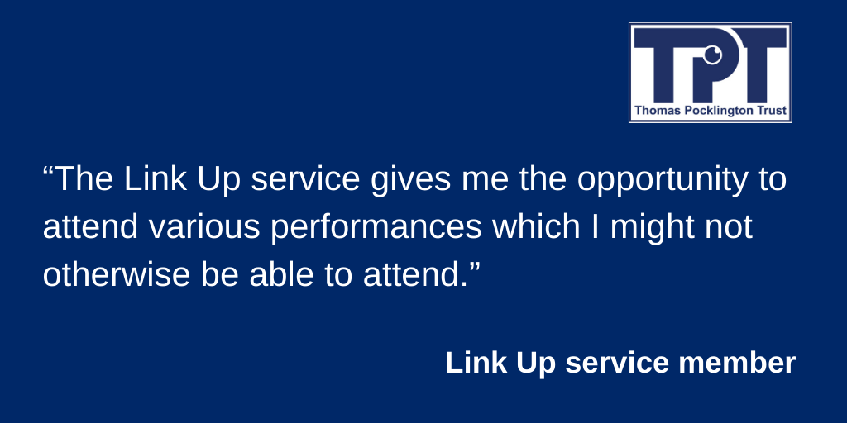

This kind of content (images that display only text - generally a quote or slogan) is frequently used on social media, especially Instagram. They can be very impactful and engaging but without an alt text description are completely inaccessible for blind and partially sighted users. Here is the alt text created for the above example:
The image shows a quote: “The Link Up service gives me the opportunity to attend various performances which I might not otherwise be able to attend.” The quote is shown on a blue background with the TPT logo in the top-right corner of the image, and is from a Link Up service member.
Photograph/ stock image

The alt text for this image is:
A group of people sitting at a table drinking coffee smiling.’

The process for applying a description to an image varies from platform to platform, but all the major social media channels provide the necessary feature you can use to ensure an image is accessible.
Twitter:
After you have uploaded the image you want to post, click/tap the ‘Add description’ link (on mobile devices tap the ‘ALT’ button located in the bottom-right corner of the image preview). You will then be able to enter your text description of the image. When you’re done, hit the ‘Apply’ button. The image is now ready to post and will be accessible for blind and partially sighted users.
Facebook:
At the time of writing, Facebook’s image description feature is not fully supported on mobile devices but works well on the desktop version.
Desktop: Once you have uploaded your image to your post, click/tap the ‘Edit photo’ button. This appears as a small paintbrush icon in the bottom-right corner of the image preview. The ‘Edit photo’ page will appear, select the ‘Alt text’ button/tab, navigate to the alternative text edit box and enter your text description of the image. Click ‘Save’. Your image will now have the text description applied to it.
On Apple mobile devices you can add alt text to an image after you have posted it, by navigating to the post, pressing down on the image, selecting ‘Edit alt text’, enter your text description, and hit ‘Save’.
At the time of writing the Android version of Facebook does not provide a feature for adding an image description, however, you can add this within the body content of the post.
LinkedIn:
LinkedIn’s alt text feature is only available on the desktop version. Upload your image to the post, hit the ‘Add alt text’ link/button (top-right corner of the image preview), navigate to the edit/text box provided, and enter your text description. Click ‘Save’.
If using a mobile device add your image description within the body content of the post.
Instagram:
After uploading an image to Instagram, click next, the ‘New post’ screen will appear with several options. Click ‘Advanced setting’ at the bottom, scroll down to ‘Accessibility’ and find the option to ’Write alt text.’ Click ‘Done’ at the top right-hand corner to save. The limit is 100 characters.

General communication tips
Large text
Creating communication material with larger text can often be beneficial for partially sighted people. Consider formatting your material for use by your members and users, different font sizes are needed by different people. It is generally recognised to use at least font size 14 for Easy Read communications.

Font
Similarly, providing the material in specific fonts may also be requested by your members and users. Some people may require their content in a particular font, however, it is advisable to use Arial unless otherwise advised.
Make the call to action accessible
If through your website, newsletter or social media content, you require some further action from someone, make sure that this call to action is accessible. This might be registering for an exercise class or buying a membership.
Make sure that any online forms are laid out in a logical manner and clearly highlight what information is required by the user.
Audio description
Videos are a great way to launch new products or services to your customers. They are increasingly used in social media posts and within digital newsletters. To make sure that your videos are accessible consider creating an alternative inclusive version that includes audio description. Audio description is the verbal description of the visual elements that appear in videos. The aim of audio description is to provide verbal information on the visual content that is essential to understand what is on the screen. Often audio descriptions occur in sections of a video where there is no audio provided in the original video.
Imagery
Using imagery that represents blind and partially sighted people, in communication and marketing materials such as videos, social media, case studies and posters, demonstrates that you are inclusive. It helps to normalise the idea of their attendance in the minds of staff and facility users.

