Accessibility and Disability Support across the Leisure and Fitness sector -

Executive Summary

A snapshot view into the support available to blind and partially sighted users, both digitally and in person when considering using gyms, leisure centres or other fitness and sports facilities.

Report delivered by All Able Ltd on behalf of Thomas Pocklington Trust

Executive Summary

Everyone should have the option to keep themselves fit and healthy and engage with their communities in ways that encourage good health such as use of leisure centres, gyms and other health, fitness, sports and leisure facilities.

Sight Loss Councils across the UK raised with Thomas Pocklington Trust issues surrounding barriers for blind and partially sighted people in using facilities that support exercise and good health.

Issues raised, covered both in-person experiences as well as the digital journeys which support sign up and booking. For example, many leisure centre operators have implemented websites or mobile applications to support users in accessing services. These applications provide users the ability to book classes and other services, but do they work for disabled users and provide useful support information?

“First time when I went to the leisure centre, I was anxious and struggled a lot, I didn't get much support and mentioned how I was going to complain to the council, but they didn't offer support or sympathy at all - I didn't complain at the time as this was a long time ago and I wasn't as confident as I am now”

“The end result is that the various barriers put in front of you deter most blind people from going to the gym.”

This report aims to deliver a comprehensive snapshot of what barriers are currently affecting the blind and partially sighted leisure experience. The outcomes of which should raise awareness of issues across both the blind and partially sighted community as well as among leisure facility providers to encourage them to take positive action.

The findings of this report show a clear difference in outcomes for blind and partially sighted users when compared to non-disabled leisure centre visitors. A lack of Information that would be required for these users to make informed decisions, unusable digital booking routes, and user testimonials demonstrate several trends in barriers for leisure centre use.

This is backed up by findings from others. For example in the UK Active Everyone Can report (2023), ‘survey respondents were asked about what has stopped them from using facilities, and lack of confidence (33%) and concerns about being judged (28%) were rated as second and third after cost (47%).’

“From my experience when dealing with staff they weren't very helpful and they didn't come up with any ideas or solutions… I got the impression that they didn't really want to deal with me.”

The research has found that at every step of the journey, there are opportunities to help improve the leisure industry support for blind and partially sighted user experience.

The research was broadly split into three areas, a user survey, review of the information available on the website and how accessible the websites were, direct staff engagement and responses over the phone. These approaches were chosen to give us a broad understanding of the issues facing blind and partially sighted users across the different sign up and support routes available.

Survey findings

“Nerve wracking, I half expected them to say we can’t have you here for health and safety reasons”

The survey responses from blind and partially sighted users consolidate the poor responses the research team had through the phone interactions.

The responses were broadly grouped into the following themes:
- First impressions
- Finding information
- Digital systems
- Gym equipment / facilities
- Personal trainers
- Staff
- Lack of independence
- Etiquette

The majority of responses identified accessibility barriers, poor responses from saff, dismissive attitudes or a lack of support. Even where good experiences were discussed, these still referred to overcoming earlier barriers or came with caveats.

“Most barriers are put up early on. If you get past them, staff in my case have invariably discovered that things are far simpler than they imagined.”

“I stopped going to the gym since obtaining my disabilities and losing my vision when I did attend some gyms to check for accessibility. I found that there were many barriers that there was not really many options apart from hiring a personal assistance trainer if I wanted to reach my goals and actively use all the machinery in the gym.”

“Gym staff introduced me to the class teacher. I explained where it was best for me to stand so I could see them best. It was discreet so I blended in with others.”

The responses demonstrate that there needs to be a significant culture shift in how staff address disabled customers, and training and resources need to be provided to help encourage more supportive informed action.

“Being refused access because of the [Guide] dog is demoralising and makes me feel worthless. Not being willing to adjust a policy or system from one guide dog owner to the next has also caused issues including health and safety issues for me and fire safety issues."

“If a disabled person enquires about using the gym, be open minded. Do not go with ‘this is what we do with X person so that’s what we will do with you’. I think the most important things are to be welcoming, invite us along to get a feel of the facility and ask us what we want to get out of using the centre and work together to come up with a plan that works for the individual.”

Website findings

If a blind or partially sighted user wanted to get information about a leisure centre we know that in the majority of areas, this information does not exist or is not particularly detailed, often cannot be found online, and in most cases, even if the information was present, could not be accessed because of the poor accessibility of online routes. The results showed significant room for improvement across all three types of accessibility information:

- 84.6% did not have any disability support information or had only the briefest mention of disability support.
- 47.1% did not have any facilities support information or had only single sentence answers that did not provide any useful detail. For example "The centre provides a full range of accessible fitness facilities all on one site".
- 61.7% did not have any website accessibility information.
- Out of the three information types, facilities information was the most prevalent, with 31.7% having some level of guidance, often in the form of brief bulleted lists, but even then, these could be expanded to provide more comprehensive information.

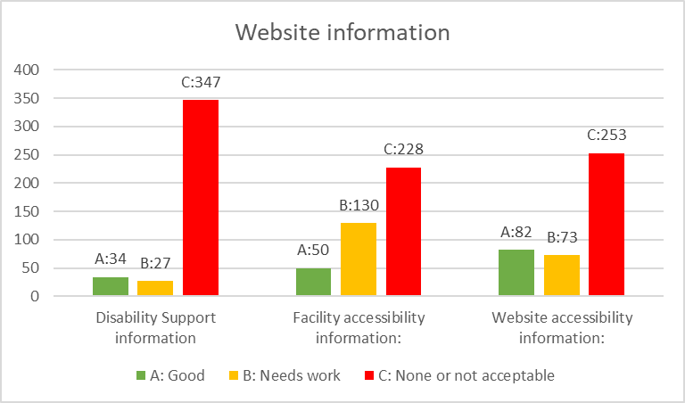
Figure 1: Website information presence and quality results
“Firstly, the website to make bookings was inaccessible to me. The organisation did have an app that could also be used, but that was also inaccessible.”

The findings show a relatively even distribution when it comes to website accessibility features, with most being in the “Needs work” and “Inaccessible” categories. There were often significant barriers on the website to sign up, bookings or finding out important information.

- 47.6% of centres were in the “Needs work” category.
- 45.4% of centres were in the “Inaccessible” category.
- Only 6.5% of centres could be considered to have a “good” level of technical accessibility of which there were even results for both public and private organisations.

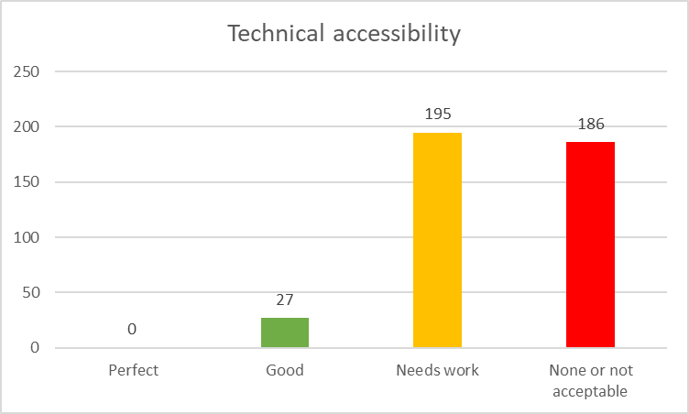
Figure 2: Technical accessibility summaries

The general level of website accessibility was relatively low with many opportunities for improvement. Some of the changes required may involve more in depth work, significant redesigns or switching third party products. As the main route for information, and the one directed to from most phone interactions, it is vitally important that websites are accessible to all users.

On site engagement

It is ‘hit and miss’ if blind or partially sighted users try alternate contact routes such as calling a location. Over half of the locations tested (57.1%) did not answer the phone, and out of the remainder that did, it was a relatively even chance whether users would get a helpful or at least well-meaning response or have a negative experience.

“I wanted to find out how to book a session at the gym. I found the information and called the centre on the phone to book.”

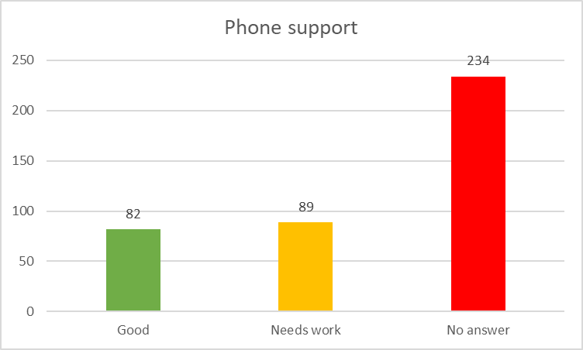
Figure 3: Contacting locations by phone results

Although contacting directly and speaking to on site staff is likely to produce more useful information than can often be found on websites, this is not to say that it is always an effective solution. While there were many positive interactions, there were also many disappointing interactions. However, when staff are able to give advice, and are supportive towards the queries, their local knowledge of the facilities was a useful start.

Recommendations

“Acknowledge that disabled people work out. Treat them as customers first and disabled people second.”

Action is required to improve the experiences of blind and partially sighted users across the leisure facilities sector which needs to take actions on improving information availability and quality, improving digital routes, and serious changes to the way staff in particular interact with disabled users.

Leisure centres should seek to deliver an accessible-by-design approach in their facilities, and for their digital estates, and should be fostering a person-centric approach to the way they deal with all customers.

Although there is a clear willingness within the sector to be more inclusive, there is still work to do to build staff awareness of accessibility barriers and to practically engage with simple steps to minimise those barriers. This report makes the following recommendations:

Recommendation 1: Leisure centres should immediately aim to update the accessibility information available on their websites, apps and given by staff over the phone which should all be consistent across sources.

Recommendation 2: Leisure centres should conduct thorough accessibility testing of their websites and mobile applications including those that have been procured through third parties.

Recommendation 3: Leisure centres should immediately publish on their websites, user friendly (i.e. non-technical and plain English) accessibility information about their websites and applications (including those that have been procured through third parties) based on the testing completed as part of recommendation 2.

Recommendation 4: For future procurement exercises leisure centres must demand comprehensive accessibility information from suppliers as part of the procurement exercise and only seek to engage suppliers who can show a high level of accessibility conformance.

Recommendation 5: Leisure centres should avoid the use of overlay products as described in the Overlay Fact Sheet.

Recommendation 6: Leisure centres must effectively resource and support staff awareness training to encourage organisational adoption of more inclusive accessibility practices.

Recommendation 7: To develop a more person-centric approach staff should be encouraged and supported to ask respectful questions to elicit more information about user requirements as appropriate in order to ensure that needs are met. Clear guidance and processes should be put in place to help staff know what is reasonable to ask and suggest initially.

Recommendation 8: Leisure centres must ensure access to effective training for blind and partially sighted users. Users should be supported to develop skills and confidence in the use of all equipment and alternative techniques, as well as being encouraged to self-advocate.

Recommendation 9: Leisure centres should seek to raise awareness of accessibility principles for all users of leisure facilities.

Recommendation 10: Personal trainers should not be a surrogate for inclusive practice. Leisure centre staff should understand how to discuss where and when a personal trainer may be an appropriate reasonable adjustment.

Recommendation 11: Leisure centres should review their current facilities against physical access minimum standards (such as Sport England guidance on accessible design of leisure facilities), and advanced good practice to create roadmaps to introduce more accessibility features in future.

Recommendation 12: Leisure centres should work with equipment suppliers to push accessibility features as a must have in future equipment purchases.

References

- AccessAble https://www.accessable.co.uk/

- All Able (2020), Accessibility Statements Grading Methodology. Available from: https://www.allable.co.uk/research/accessibility-statements-v4#h.ioceu2wn3i8k

- Disability Confident https://www.gov.uk/government/collections/disability-confident-campaign

- Karl Groves (2021), Overlay Fact Sheet. Available from: https://overlayfactsheet.com/#main

- Make Things Accessible (2022), Accessibility Statements: What are they? Available from: https://www.makethingsaccessible.com/guides/accessibility-statements-what-are-they/

- Make Things Accessible (2022a), Procurement accessibility guidance. Available from: https://www.makethingsaccessible.com/guides/procurement-accessibility-guidance/

- Make Things Accessible (2022b), Semi-automated accessibility testing tools. Available from: https://www.makethingsaccessible.com/guides/semi-automated-accessibility-testing-tools/

- Sport England (2012), Design and Cost Guidance. Available from: https://www.sportengland.org/guidance-and-support/facilities-and-planning/design-and-cost-guidance

- Thomas Pocklington Trust (2021), Making Colleges Accessible. Available from: https://www.pocklington-trust.org.uk/student-support/professionals/making-college-accessible/

- Thomas Pocklington Trust (2021), Technology and accessibility in further education (FE) executive summary. Available from: https://www.pocklington-trust.org.uk/wp-content/uploads/2021/11/Executive-Summary-Technology-and-accessibility-in-further-education-FE.pdf

- UK Active (2022), Digitally Fit: Rising to consumer demand for the connected digital experience. Available from: https://www.ukactive.com/wp-content/uploads/2022/10/Digitally-Fit-ukactive-x-Sport-England-x-Rewrite-Digital.pdf

- UK Active (2023), Everyone Can: The experiences and expectations of the 1 in 5, making physical activity accessible and welcoming for all. Available from: https://everyonecan.ukactive.com/

- UK Active (2023a) An evidence review of the current barriers and facilitators of disabled people’s engagement with gyms, fitness and leisure centres. Available from: https://everyonecan.ukactive.com/

- UK Coaching Team (2022), Inclusive Facilities: Supporting People With a Visual Impairment. Available from: https://www.ukcoaching.org/supporting-people-with-a-visual-impairment

- UK Government (2014), Disability Confident employer scheme. Available from: https://www.gov.uk/government/collections/disability-confident-campaign

- UK Government (2018), The Public Sector (Websites and Mobile Applications) (No.2) Accessibility Regulations 2018. Available from: https://www.legislation.gov.uk/uksi/2018/952/pdfs/uksi_20180952_en.pdf

- W3C (2018), Web Content Accessibility Guidelines (WCAG) 2.1. Available from: https://www.w3.org/TR/WCAG21/

- WelcoMe https://www.wel-co.me/

The Research Team



All Able Ltd
All Able is a consulting company committed to using our expertise to help public sector organisations remove barriers and deliver accessible and inclusive services that work for everyone. We believe that everyone should have equal opportunity to utilise public services, get an education, and engage with their communities to live an enjoyable and independent life.

Web: www.allable.co.uk
Twitter: @All_Able
LinkedIn: @all-able-ltd

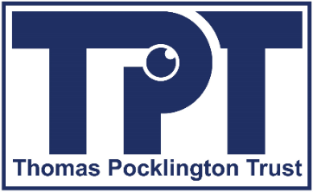

Thomas Pocklington Trust (TPT)
Thomas Pocklington Trust is a national charity dedicated to enabling and empowering blind and partially sighted people of all ages to live the life they want to lead. We are committed to increasing awareness and understanding of their needs and aspirations, to working with partners and to developing and implementing services which meet these needs to increase independence and improve lives.

Web: www.pocklington-trust.org.uk
Facebook @thomaspocklingtontrust
Twitter: @TPTgeneral
LinkedIn: @pocklington-trust

