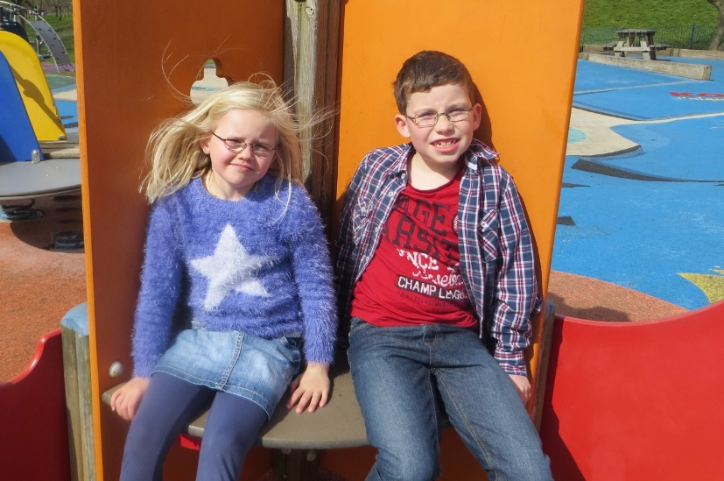
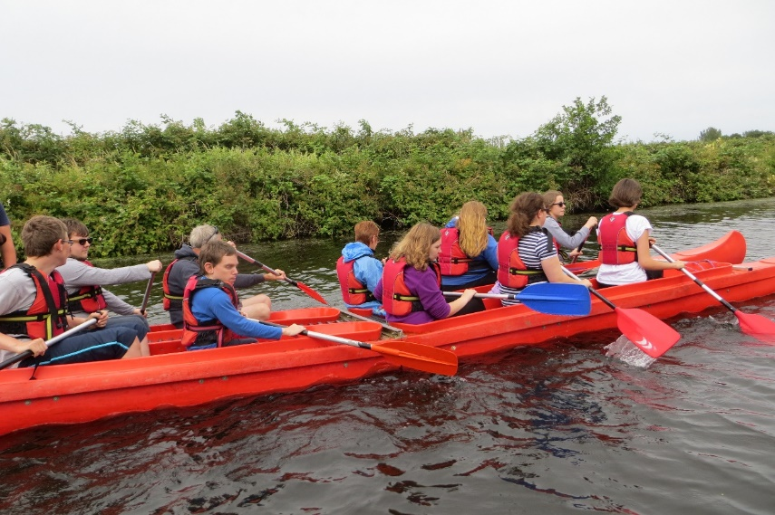

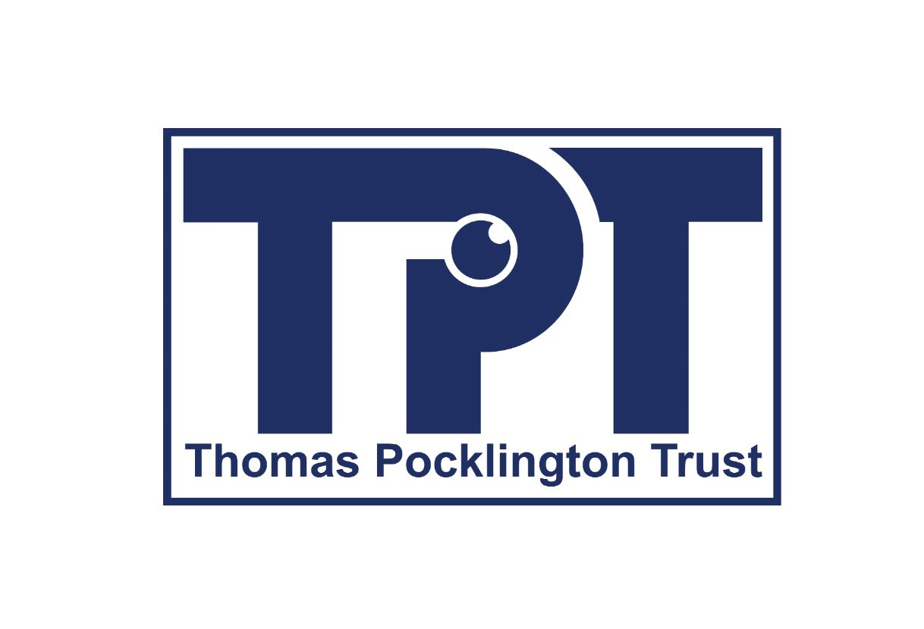

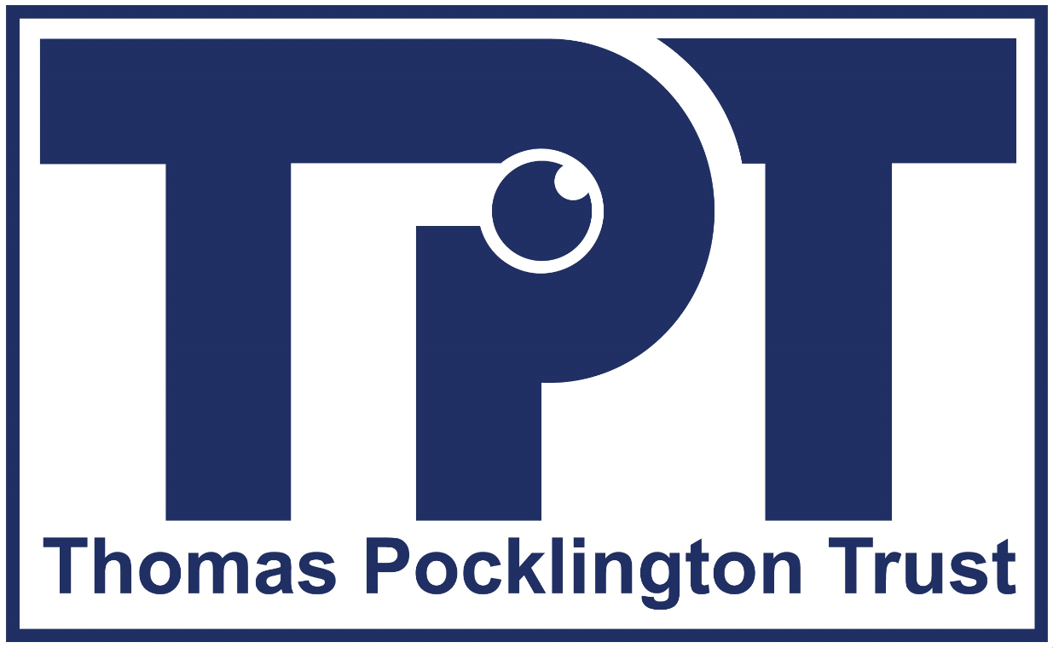

Service Framework for Charities
Supporting Vision Impaired Children, Young People and Families

Vision Impaired Children Young People and Families Framework
A guide for local sight loss charities and groups planning to develop and deliver services to children, young people, and families.

Introduction
The Thomas Pocklington Trust (TPT) CYPF Framework was designed in 2018 to support local sight loss charities across the country who wanted to develop or re-design their CYPF services. Following the 2020 evaluation of the Framework, Version 2 has been developed to further support and enhance the CYPF offer for local charities, as well as developing an additional suite of resources.

How to use the Framework
This Framework has been designed for use, primarily by local sight loss charities who do not yet deliver any CYPF services. The premise is that each section of the Framework will guide charities through what they need to consider when designing services aimed at CYPF, covering governance through to fundraising and promotion.

The Framework can be used in conjunction with the additional resources TPT has provided to support local charities to develop and deliver CYPF provision. This Framework has a notes section for charities to use and a handy acronym guide at the end of the document, which lists the acronyms used throughout, as well as some key professional roles working with CYP.

For further information and support in setting up and developing CYPF services please contact the TPT CYPF team at cypf@pocklington-trust.org.uk

Governance
Area covered |  | Considerations |  |  | Solutions |  | Notes
Governance |  | Representation on Board of Trustees  Trustee indemnity |  |  | Complete a skills audit of the board of trustees.  Diversify the trustee board to include a Parent/Carer or vision impaired younger person (18+) and/or professionals working in the VI CYPF field.
Constitution |  | Is the constitution or governing document relevant for CYP delivery?  Do the charities charitable objectives reflect a change in delivering services to CYP? |  |  | CYPF provision may need to be added to the charity constitution.  May need to amend charitable objectives to include supporting children and young people – examples available upon request.  Consider changing the charitable status to CIO, for example if your existing charitable structure does not permit you to undertake certain activities or you need to review the financial risk levels especially if you are delivering under local authority contract.
Risk register |  | Has the risk register been refreshed and incorporates CYPF work? |  |  | Ensure the charity’s risk register is updated to incorporate CYP work. Risks around working with CYP to be incorporated and reviewed at regular intervals. This can include funding risks to service provision as well as safeguarding risks and staffing and volunteering provision.
Policies |  | Appropriateness of procedures and policies |  |  | May need to amend or add additional policies.  Consider completing a policy audit.
Safeguarding |  | Ensuring safety of CYPF |  |  | Best practice, staff and volunteers have an enhanced DBS check every three years.  Ensure there is a Level 3 Children’s Safeguarding Manager, and that all staff and volunteers have a Level 1 safeguarding qualification. See the NSPCC website for more information.  There should be a trustee with safeguarding role.
GDPR and confidentiality |  |  | Ensuring all information is held and handled securely, and with consent. |  |  | Ensure you are fully GDPR compliant and have up to date permissions, which include how to contact individuals.  Parent/carers need to give permissions for all young people aged under 18.  Comply with confidentiality / GDPR policies to secure all information.  Review any case study and marketing materials for expiration of consent.
Rights and legal information |  |  | The three main pieces of legislation governing children’s rights are: |  |  | The Children and Families Act  The Equality Act  the SEND Code of Practice
First Aid | What first aid provision is there?  Is there a paediatric First Aider? |  |  | Staff have paediatric First Aid training and that at least one trained individual is present at all events, British Red Cross and other local providers may offer training.
Insurance | Is current policy suitable for CYPF and off-centre activities? |  |  | Check current insurance to ensure that it is suitable for CYPF activities, to cover lone working, home visits, volunteers, drivers (if required) and habilitation specialists if necessary.
Risk assessments | Tailor risk assessments for CYP provision |  |  | Risk assessments required for all activities.  If events held at external venues – they should provide their risk assessment and policy.  As part of the risk assessment process, also include environmental risk assessments. i.e. level access to buildings, lighting, contrast, trip hazards.  Staff and volunteers have read and understood the risk assessment, prior to the event/activity.  Depending on the organisation there may be a requirement for additional risk assessments for different roles for example habilitation specialists.  Have contingency plans for back-up staff for events, especially for events out of normal working hours to manage risk and staff/child ratios.

Planning
Area covered | Considerations | Solutions | Notes
Feasibility / viability study | Is there a demand or need for this service in your area?  Are there others offering this service locally? | Engage with QTVIs and habilitation specialists to determine the need for CYPF services in your area.  Use RNIB FOI request and local authority / health care data to assess numbers of VI CYP in your area.  Investigate if there are other services already offering provision – establish if they popular services or struggling to engage with CYPF.  If possible, survey possible potential beneficiaries to gauge interest.
Goals | Do your goals reflect your charity’s mission statement? | Review your mission statement and charitable objectives. Check your goals align with these.  Goals should be:  - Specific  - Measurable  - Attainable  - Relevant  - Time Bound  Review your goals regularly, to check they are current and reflective of what you are doing.
Sustainability | Are the CYPF services provided able to be maintained or grown. | When setting up services, it is crucial to ensure that the charity can fund them for their duration.  As part of any sustainability review of services, an evaluation needs to be completed.  Consider working in partnership with other organisations if not able to deliver or maintain services independently; this can be influential with funders and commissioners who are interested in funding consortia bids.  Any sustainability review for services should consider succession planning in the event of key workers no longer in post, how would the service continue to operate.  Ensure that any Income Development Strategy factors in sustainability for services.

Outputs, Outcomes, and Impact
For more support and guidance with this, please contact us directly.
Area covered | Considerations | Solutions | Notes
Assessing your provision | Ensure you have effective systems in place for measuring outputs, outcomes, and impact | Keep accurate records outputs for all events; numbers and ages attended, additional needs, specify if they were VI CYP, sibling, parent or carer, or volunteer.  Assess the impact your work is having on the CYPF, both during and after the activity, by assessing feedback, conducting interviews or focus groups or through formal evaluation.

Consultation and Evaluation
Area covered | Considerations | Solutions | Notes
Consultation | Are you delivering what CYPF want? | Consult regularly with your beneficiaries to find out what they would like to see on offer, considering your staffing and budgetary restrictions.  Engage with your beneficiaries through surveys, focus groups and social media and outcome reviews with individuals.
Evaluation | Evaluation is vital to monitor effectiveness and in applying for future funding | Evaluate all activities including views of both CYP and adults to find out what is and is not working, and differing ways of delivering services.  Evaluation tools can include handouts including all formats as needed, opportunities for tactile art feedback, audio recordings – which can be very easily done on mobile phones and Survey Monkey which meets GDPR requirements and is accessible.

Resources
This section covers financial and employment resources.
Area covered | Considerations | Solutions | Notes
Staff and recruitment | Does the charity have safe recruitment policies and procedures in place?  Qualifications and experience  Does the role require the employee to be a driver?  Staffing ratios | Ensure that Safe Recruitment Procedures are in place.  Advertise for staff through:  - National Charity Job websites  - Local Authority Job websites  - Local CVS or NCVO websites  - Local paper and radio  - Local job centres and employment agencies.  Qualifications and Experience  GSCEs or equivalent with IT knowledge which needs to be relevant to the job role.  Previous experience of working with children, experience of working with children with additional needs, if the service is to be delivered to children with PMLD or MSI.  Staffing Ratios  CYP may attend events with or without their parent / carers. If you are in sole charge of these children, staffing ratios according to NSPCC are as follows:  - 0 - 2 years - one adult to three children.  - 2 - 3 years - one adult to four children.  - 4 - 8 years - one adult to six children.  - 9 - 12 years - one adult to eight children.  - 13 - 18 years - one adult to ten children.  The National Education Union states that pupils with SEND are at particular risk in practical activities and may require additional support; this would be identified during the risk assessment.
Training and continuing professional development | What opportunities are there for training and continuing professional development for your CYPF staff | National and Local conferences enable you and your staff to share ideas, learn new skills and network with others in the sector.  - Sight Village, Vision UK, Visionary and VIEW conferences.  - Attend sight specific conferences related to CYP  - Pan disability exhibitions are a good place to learn about others.  - Online learning for staff and volunteers should also be considered.

Income Generation
Income generation | Does the income generation strategy or fundraising strategy reflect new areas of service delivery? | Review the income generation strategy to incorporate new areas of service delivery.  Does the service delivery plan corelate with the income development strategy? Are proposed service delivery costs and overheads achievable through the income development strategy?  As part of the income development strategy, consideration on community fundraising, involving families to support the charity can be factored in.
Community fundraising | Family friendly fundraising  Online fundraising  Public fundraising  Local fundraising | Supermarkets run various token, membership card and other fundraising initiatives.  Sponsored events, e.g. Marathons  Local Fundraising events with families  Charity of the Year – supermarkets, banks, businesses etc.  Raffles and auctions  Major donor events  Online and text-based fundraising – these do have admin costs associated with them.

Area covered | Considerations | Solutions | Notes
Trusts and grants | Applications specifically for CYPF – often a very different source of funding than for adults. | Local CVS (part of the NCVO) can give information on funding providers. Some may provide a funder finder search.  Daily GRIN updates are useful for grant information  Local Authorities may offer Aiming High or Short Breaks funding.  Major grant givers: Children in Need, The National Lottery Community Fund.  Local sources include Water Boards, Lions Clubs, Round Table, Rotary Clubs and Masons.  Thomas Pocklington Trust can provide funding for projects which support improved outcomes for blind and partially sighted people.
Sponsorship | Can you advertise someone else’s service to generate income? | Consider sponsorship for newsletters, T shirts or badges and stationery.  Check that sponsorship does not compromise the ethos of your organisation or impact on your reputation.

Beneficiaries
Area covered | Considerations | Solutions | Notes
Eligibility criteria for accessing services | What age groups can access services?  Does the service support CYP with MSI or PMLD?  Are services only available to vision impaired CYP? | 0 – 25 is the age range for providing services for CYPF with disabilities.  As part of service design and recruitment, clarification on whether the project can deliver services to MSI and PMLD children needs to be determined. The charity may decide that it offers services to children without additional needs.  Integrate VI CYP and siblings at events and activities.
Referrals | What agencies are going to refer into the service? | Develop a simple referral pathway for all professionals.  Engage with Special Needs and mainstream schools in the area.  If there is an eligibility criterion, ensure that this is clearly explained to professionals and parents.
Parent/carers/ siblings/friends and other family members | Families may struggle to attend events if siblings are not included. | Open events up to parents, carers, siblings, and members of the wider family network.
VI parents | Some families will have parents with a vision impairment. | Provide information about events and activities in accessible formats.  Consider forming a peer support group for VI parents.
Buddying and groups | Are families feeling confident to attend events when they do not know anyone? | Use a buddy or mentoring system for new families. Pairing families with a more established family with similar age / eye condition/additional needs so they are welcomed to the group.
Checking up on new and hard to reach families | Are families attending once and then not returning? | Follow up with new families and existing ones to check gain feedback and support to resolve any potential barriers to engagement.

Marketing and Promotion
Area covered | Considerations | Solutions | Notes
Advertising activities/events | Low rates of engagement  Advertising is not accessible | Advertise events using:  - Newsletters (paper or digital)  - Promote events with professionals  - Social media  - Posters within the community  - Advertise events 3-6 months in advance
Social media | Many families use social media | Closed groups can be best from a confidentiality and safeguarding perspective.  Clear guidance on how the group is monitored needs to be outlined when people join.  Establish how the group will be managed. Staff, volunteers or self-governing.  Photo consent forms to be signed before sharing and publishing any content. Updated frequently.  Ensure emails / social media posts are fully accessible.  Consider your digital safeguarding responsibilities and GDPR with online groups.

Newsletter
Area covered | Considerations | Solutions | Notes
Newsletter | Keeping families informed of latest news, information, and events | Newsletter can include the following:  - News from the sector  - General information about the group  - Information relevant to any themed offer  - What is on locally and nationally  - Event and activity reports  - Family news – contributions from families  - Case studies  - Birthdays  - Fundraising, committee and office news  - Upcoming events run by the group  - Advertising  - Second-hand equipment for sale
 | Newsletter format | Newsletters can be offered in:  - Hard copy  - PDF online  - Text only large print  - Braille  - Audio  - Mailchimp or other online newsletter platforms

Partnership working
Area covered | Considerations | Solutions | Notes
Nationally | Duplication of events/activities and services.  Joint funding applications – how does this impact on your own KPIs? | Many national charities are involved in various aspects of CYPF service delivery and will be able to enhance your offer, through their specialisms:  - Thomas Pocklington Trust  - RNIB CYPF Services  - Guide Dogs CYPF Services  - LOOK  - RSBC  - VICTA  - SENSE  Sports specialists:  - British Blind Sport  - Disability Sports England  - Disability Sport Scotland  - Disability Sport Wales  - Disability Sport NI  - Goalball UK  - Visually Impaired Tennis  Collaborative work can enhance your offer and minimise the financial impact on the charity.  Working in partnership may mean that you need to review your outcomes and outputs for your projects, to align with other stakeholders and funders.
Locally |  | Consider joint events with other local disability groups including your local branch of the National Deaf Children’s Society or find others through the organisation Contact.  Work with local sports providers including football, rugby, or other association to deliver activities.

Professionals

Community paediatricians see children and young people in the community and out-patients departments
Consultant ophthalmologists specialists in eye and vision care
Family support officers offer practical help and emotional support to families .
Habilitation teams support children with visual impairment and their families
Health care professionals provide essential services that promote health, and deliver health care services to individuals, families, and communities
Health visitors work with families who have pre-school-age children
Paediatric ECLOs work specifically with families and vision impaired children to refer into appropriate services
Paediatric orthoptists investigate, diagnose, monitor, and manage visual disorders related to eye development
Optometrists (previously known as ophthalmic opticians) are specialists trained to examine the eyes to detect defects in vision, signs of injury, diseases, or abnormalities.

Acronyms
CVI Cortical/Cerebral Vision Impairment
CVS Community and Voluntary Services
CYP Children and Young People
CYPF Children, Young People and Families
DBS Disclosure and Barring Service
FE Further Education
GRIN Grants Resources Information Network
HE Higher Education
HI Hearing Impairment
MSI Multiple Sensory Impairment
NCVO National Council for Voluntary Organisations
NSPCC National Society for the Prevention of Cruelty to Children
QTVI Qualified Teacher for the Visually Impaired (also known as VI Advisory Teacher)
PMLD Profound or Multiple Learning Difficulties
SEND Special Educational Needs and Disabilities
UCAN Welsh VI Drama Group

For more information please contact:
Children, Young People and Families Team, Thomas Pocklington Trust
Email: cypf@pocklington-trust.org.uk Head office: 020 8995 0880 Website: www.pocklington-trust.org.uk

